PharmaTrack — Pharmacy Inventory & POS System
  - COE 454 Client Project — Weeks 1–3 Documentation Package
Table of Contents

Problem Discovery Note
COE 454 — Week 1 Deliverable 3 (max 1 page) Team: [TEAM NAME] · Codename: PharmaTrack · Date of Visit 1: [DATE]
Field | Detail
Business name | [PHARMACY NAME — from Site Visit 1 log]
Location | [SUBURB, e.g. Ayigya / Bomso / Kotei], Kumasi — off-campus, KNUST environs
Sector | Retail pharmacy (clinics & pharmacies — eligible sector, brief §3.1)
Contact | [OWNER / SUPERINTENDENT PHARMACIST NAME, ROLE]
Registration | [Business Operating Permit / Pharmacy Council registration — sighted? Y/N]

Observed problem
The pharmacy runs its entire sales and stock operation on QuickBooks Desktop Point of Sale 19.0 (Multistore level) on a single Windows 10 computer. During the visit we observed staff making sales and maintaining the item list in this software. Three compounding problems were identified:
- The software is discontinued. Intuit ended QuickBooks Desktop POS on 3 October 2023 — no security updates, no technical support, and no ability to obtain or re-activate licenses. If the till PC fails, the pharmacy cannot reinstall its own system; the business is one hardware failure away from reverting to paper.
- No batch or expiry-date tracking. QB POS tracks only a quantity-on-hand per item. Medicines expire; staff manage expiry by physically inspecting shelves. Expired stock is a direct financial loss and a regulatory risk (Pharmacy Council of Ghana inspections). (Severity and frequency to be quantified in the Visit 2 interview.)
- Data is trapped on one machine. No off-site backup, no remote access for the owner, one till only. Reordering relies on a static “reorder point” field per item and manual review; low-stock and expiry situations are discovered, not signalled.

Why it matters to the business
- Continuity risk: a dead PC or corrupted database ends digital operations permanently.
- Money: expired stock is written off; stock-outs of fast movers lose sales; both are currently managed by memory and shelf checks.
- Compliance: expiry control and sales records are inspection items for a licensed pharmacy.
- Owner visibility: no way to see sales or stock without standing at the till.

Proposed direction (subject to Visit 2 requirements interview)
A web-based inventory + POS system the pharmacy owns: medicine catalogue with batch/expiry tracking, barcode-driven sales with printed receipts, purchase orders and stock receiving, automatic low-stock and expiry alerts, role-based accounts (owner, pharmacist, cashier), and an offline-tolerant till for internet outages — with the existing QB item list migrated in via CSV export so the pharmacy does not start from zero.

Team Charter — [TEAM NAME] (Codename: PharmaTrack)
COE 454 — Week 1 Deliverable 1. Complete, print, sign (all 7 members), submit before first client visit. (1–2 pages per brief §4.1.1.)

1. Members & roles (binding for project duration — brief §2)
# | Full name | Student ID | Role
1 | [NAME] | [ID] | Project Manager
2 | [NAME] | [ID] | Business Analyst / Client Liaison
3 | [NAME] | [ID] | UX / Design Lead
4 | [NAME] | [ID] | Backend Engineer
5 | [NAME] | [ID] | Backend Engineer
6 | [NAME] | [ID] | Frontend Engineer
7 | [NAME] | [ID] | QA / Documentation Lead
(Adjust the 1–2 backend/frontend split to your team’s actual skills.)

2. Communication & working agreement
- Channel: WhatsApp group “[GROUP NAME]” for daily coordination; GitHub issues for all technical and architectural decisions (brief §2.2 rule 2).
- Standup: every [DAY] at [TIME], 15 minutes, [LOCATION / online]. PM records attendance and blockers on the GitHub project board.
- Working hours: members respond to team messages within [X] hours between [START]–[END]; deep work sessions [DAYS/TIMES].
- Tooling: GitHub repository + GitHub Projects board (visible to lecturer). All code via pull request with ≥1 peer review; no direct pushes to main.

3. Decision-making & conflict resolution
- Attempt consensus within the relevant role pair (e.g., the two engineers for a technical call).
- If unresolved in 24 h, the role owner decides (BA for requirements, UX Lead for design, Backend Lead for architecture) and records the decision as an ADR or issue.
- If the disagreement is cross-cutting or affects the client, the PM calls a vote; simple majority; PM breaks ties.
- Client-facing commitments are made only by the BA or PM, never individually.

4. Contribution expectations (“full contribution” per role)
Role | Full contribution means
PM | Board current, weekly standup held, deadlines tracked, blockers escalated ≤24 h
BA | Every client interaction documented and signed; requirements doc current
UX Lead | Wireframes before build; usability check before every demo; mobile/3G verified
Engineers | Assigned issues delivered per sprint; PRs reviewed within 48 h
QA/Docs | Test plan executed each sprint; README always reproducible from scratch

5. Consequences for non-fulfilment
- First lapse: raised at standup, noted in minutes, recovery plan agreed.
- Second consecutive week: PM notifies the lecturer in writing (required by brief §2.2 rule 5) and the peer-evaluation impact is made explicit to the member.
- Persistent non-contribution is reflected honestly in the confidential Week 9 peer evaluation (30% weight within team marks).

6. Signatures
Member | Signature | Date
1.
2.
3.
4.
5.
6.
7.

Requirements Document / Software Requirements Specification
Project: PharmaTrack — Pharmacy Inventory & POS System Course: COE 454 — Week 2 Deliverable 1 (structure per brief §4.2.2) Version: 0.9 (draft — items marked ⏳ must be confirmed in the Site Visit 2 interview) Owner: Business Analyst · Reviewed by: full team
This document serves as both the course Requirements Document and the project’s Software Requirements Specification (SRS). Sections follow the brief’s required structure, extended with business rules, assumptions, and constraints per IEEE 29148 practice.

1. Business context
[PHARMACY NAME] is a licensed retail pharmacy in [SUBURB], Kumasi, within the KNUST environs. It serves walk-in retail customers — students, residents, and nearby workers — selling prescription and over-the-counter medicines alongside cosmetics, food & drinks, and diagnostic consumables (as reflected in the department structure of its current system). The pharmacy operates [⏳ N] tills with [⏳ N] staff: [⏳ owner/superintendent pharmacist, pharmacist(s), counter assistants/cashiers]. Daily transaction volume is [⏳ N] sales/day across a catalogue of [⏳ ~N thousand] stock items.

2. Problem statement
The pharmacy’s sales and inventory run on QuickBooks Desktop Point of Sale 19.0 (Multistore), installed on a single Windows 10 computer. This creates four problems:
- Unsupported platform. Intuit discontinued QuickBooks Desktop POS on 3 Oct 2023. There are no security updates, no support, and no way to obtain new licenses. A hardware failure of the till PC would permanently end the pharmacy’s digital operations, because the software cannot be reinstalled or re-activated.
- No batch/expiry management. The system tracks a single quantity-on-hand per item with no batch numbers or expiry dates. Expiry control — a regulatory obligation for a licensed pharmacy — is done by physically inspecting shelves, and expired stock is discovered late, after the money is already lost.
- Reactive stock control. Reordering depends on a static per-item reorder-point field and manual review. Stock-outs of fast-moving items and over-stocking of slow movers are discovered at the shelf, not signalled by the system.
- Data confinement. All records live on one machine with no off-site backup and no remote visibility. The owner cannot see sales, stock, or cash position without being physically at the till.
The problem is the pharmacy’s operational dependence on an unsupported, single-machine system that cannot manage medicine expiry — not the absence of any particular product.

3. User personas
(Draft personas built from Visit 1 observation; validate names, ages, and details in Visit 2. Replace with real role-holders’ characteristics — do not invent quotes.)

Persona 1 — “Akosua”, Counter Assistant / Cashier
Attribute | Detail
Role | Serves customers at the till; makes ~[⏳ N] sales/day
Age / tech comfort | ⏳ [e.g., 20s, comfortable with Android smartphone, types slowly on PC]
Goals | Serve each customer fast; never sell the wrong strength/brand; balance the till at day end
Frustrations | Slow item lookup among thousands of SKUs; strip-vs-tablet quantity confusion; system freezes with no one to call
Device / connectivity | Shared Windows till PC; personal Android phone on mobile data

Persona 2 — “Mr. Boateng”, Owner / Superintendent Pharmacist
Attribute | Detail
Role | Owns the pharmacy; responsible to the Pharmacy Council for professional standards
Age / tech comfort | ⏳ [e.g., 40s–50s, uses WhatsApp and email daily, delegates PC work]
Goals | Know daily takings and what to reorder without standing at the till; never fail an inspection over expired stock; protect 20+ years of business records
Frustrations | Discovers expired stock during shelf checks; can’t check the business from home; knows the POS software is dead-ended but migration feels risky
Device / connectivity | Personal laptop + smartphone; pharmacy has [⏳ Wi-Fi? mobile-data hotspot?]

Persona 3 — “Adjoa”, Duty Pharmacist (supporting persona)
Dispenses prescription medicines, advises customers, supervises cashiers on shift, and performs stock receiving when deliveries arrive. Needs fast product/stock lookup by generic name and the authority to approve returns and stock adjustments that cashiers cannot.

4. Functional requirements (user stories)
Priorities use MoSCoW: Must / Should / Could / Won’t (this phase). MVP = all M stories. Each story becomes a GitHub issue (Week 3).

US-01 · Secure login — M As a staff member, I want to log in with a username and password so that only authorized people can use the system. - AC1: Valid credentials open a session appropriate to the user’s role; invalid ones show a generic error (no username/password hinting). - AC2: Five consecutive failures for one account trigger a 15-minute lockout, and the event is recorded in the audit log. - AC3: Sessions expire after being idle for a configurable period (default 12 h); expired sessions redirect to the login screen without losing an in-progress cart.
US-02 · Role-based access — M As the owner, I want each account to have a role (Admin, Pharmacist, Cashier, Inventory Officer, Manager) so that staff can only perform actions appropriate to their job. - AC1: A Cashier can sell and view products but cannot edit prices, delete products, or see profit reports. - AC2: Only Admin can create/deactivate users and change system settings. - AC3: Every privileged action (price change, adjustment approval, refund) records who did it.
US-03 · Medicine catalogue — M As an inventory officer, I want to create and edit products with generic name, brand name, strength, form, category, barcode, and prices so that the catalogue reflects what we actually sell. - AC1: A product records at minimum: name, generic name, strength, dosage form, category, unit cost, selling price, VAT flag, reorder level, and zero or more barcodes. - AC2: Duplicate barcode entry is rejected with a message naming the conflicting product. - AC3: Products are deactivated (soft delete), never destroyed — historical sales still reference them.
US-04 · Multi-unit packaging — M As a cashier, I want to sell in cartons, packs, strips, or single tablets with automatic conversion so that quantities and prices are always right. - AC1: A product defines a base unit (e.g., tablet) and optional larger units with conversion factors (strip = 10 tablets; pack = 10 strips) and per-unit prices. - AC2: Selling 2 strips reduces stock by 20 tablets; stock displays as “4 packs, 3 strips, 6 tablets” style breakdown. - AC3: A unit’s conversion factor cannot be edited once movements exist against it (new unit versions instead).
US-05 · Batch & expiry tracking — M As a pharmacist, I want every stock receipt recorded against a batch with an expiry date so that we always know which stock expires when. - AC1: Receiving stock requires batch number and expiry date; quantity-on-hand is the sum of non-expired batch quantities. - AC2: Sales deduct from the earliest-expiring batch first (FEFO), with manual override recorded. - AC3: A batch that reaches its expiry date is automatically excluded from sellable stock and appears on the expired-stock report.
US-06 · Barcode-driven POS sale — M As a cashier, I want to scan or search items into a cart and take payment so that a routine sale takes seconds. - AC1: A USB barcode scan adds the item to the cart instantly; unknown barcodes prompt a product search. - AC2: Search by brand name, generic name, or barcode returns results in <300 ms over a 10,000-product catalogue. - AC3: Completing a sale records line items, quantities, unit prices, discounts, payment method (cash / MoMo), amount tendered, and change; stock is deducted atomically.
US-07 · Receipt printing — M As a cashier, I want a printed receipt for every sale so that customers have proof of purchase and we have a paper trail. - AC1: Receipt shows pharmacy name/address, receipt number, date/time, cashier, line items with quantities and prices, VAT breakdown, total, tendered, and change. - AC2: Prints on 80 mm thermal paper via the browser print dialog in ≤3 s; reprint is possible from sale history (marked “REPRINT”).
US-08 · Offline-tolerant till — M As a cashier, I want to keep selling when the internet drops so that customers are never turned away. - AC1: With no connectivity, the POS continues from a locally cached catalogue; completed sales queue locally with a client-generated ID. - AC2: When connectivity returns, queued sales sync automatically; each syncs exactly once (idempotent) even across retries. - AC3: The screen shows a clear online/offline indicator and the count of unsynced sales; unsynced sales survive a browser restart.
US-09 · Purchase orders & receiving — M As an inventory officer, I want to raise purchase orders to suppliers and receive deliveries against them so that incoming stock is controlled and traceable. - AC1: A PO records supplier, expected items/quantities/costs, and status (draft → sent → partially received → received → closed). - AC2: Receiving records actual quantities, batch numbers, and expiry dates per line; over-receipt beyond PO quantity requires Manager approval. - AC3: Receiving updates stock immediately and recalculates weighted-average cost.
US-10 · Low-stock alerts — M As the owner, I want automatic low-stock alerts so that fast movers are reordered before they run out. - AC1: Each product has a reorder level; stock at or below it appears on the low-stock dashboard list. - AC2: A reorder suggestion (product, current stock, suggested quantity, preferred supplier) can be exported/turned into a draft PO in one action.
US-11 · Expiry alerts — M As a pharmacist, I want advance warning of expiring batches so that we can sell down, return, or quarantine stock before it expires. - AC1: Dashboard lists batches expiring within 30/60/90 days (configurable), with quantity and value at risk. - AC2: Expired batches are flagged for quarantine and cannot be sold; disposal/return is recorded as a stock adjustment with reason.
US-12 · Stock adjustments — M As a manager, I want damaged, lost, or miscounted stock corrected through a recorded adjustment so that system stock matches the shelf without hiding shrinkage. - AC1: An adjustment records product, batch, quantity delta, reason (damage / theft / count correction / expiry disposal), and free-text note. - AC2: Adjustments above a configurable threshold require Manager/Admin approval before applying. - AC3: All adjustments appear in the audit log and the shrinkage report.
US-13 · Daily sales & stock reports — M As the owner, I want end-of-day and periodic reports so that I know takings, what sold, and what it cost. - AC1: End-of-day (Z) report: total sales, sales by payment method, by cashier, VAT collected, and refunds for a chosen date. - AC2: Reports for any date range: sales by product/category, current stock valuation (at cost), low stock, expiring stock, adjustment/shrinkage log. - AC3: Any report exports to PDF and CSV.
US-14 · Returns & refunds — S As a cashier, I want to process a return against an original receipt so that refunds are controlled and stock is corrected. - AC1: A return references the original sale; quantity returned cannot exceed quantity sold. - AC2: Refunds require Pharmacist/Manager approval; returned sellable stock re-enters inventory against its original batch, non-sellable stock becomes a disposal adjustment.
US-15 · Customer records — S As the owner, I want optional customer profiles on sales so that regulars and credit/insurance sales can be tracked. - AC1: A sale can optionally attach a customer (name, phone); customer history lists their purchases. - AC2: Customer personal data is visible only to Pharmacist role and above.
US-16 · QuickBooks data migration — S As the owner, I want our existing item list imported so that we do not retype thousands of products. - AC1: A CSV exported from QB POS (item name, department, price, cost, on-hand qty, item no.) imports with a preview and per-row error reporting. - AC2: Imported on-hand quantities are created as an “opening balance” batch with owner-confirmed default expiry review flags.
Won’t have (this phase): multi-branch/stock transfer, e-prescriptions, insurance claim submission, supplier portal, accounting integration, demand forecasting. See §7.

5. Non-functional requirements
ID | Category | Requirement
NFR-01 | Performance | Product search returns in <300 ms and a full sale completes (scan → receipt) in <90 s at the 95th percentile, with a 10,000-product catalogue on the pharmacy’s existing hardware.
NFR-02 | Availability / offline | The POS remains usable for sales during internet outages of at least 8 hours (one full trading day); no completed sale is ever lost. Target service availability 99.5% monthly for the hosted API.
NFR-03 | Security | Passwords hashed with argon2id; all traffic over HTTPS; RBAC enforced server-side on every endpoint; OWASP Top 10 checklist passed (Week 7); privileged actions audit-logged with user, timestamp, and before/after values.
NFR-04 | Usability | A new cashier completes a supervised sale within 2 hours of first use; POS fully operable by keyboard + scanner alone; UI legible on a 1366×768 till screen and a 5” phone over 3G.
NFR-05 | Reliability / integrity | Stock quantity is never updated except through a recorded movement (sale, receipt, adjustment, return); concurrent sales of the same batch cannot oversell it (atomic, transactional deduction).
NFR-06 | Compliance | Customer personal data handled per Ghana Data Protection Act, 2012 (Act 843): minimal collection, role-restricted access, no third-party sharing. Client operational data is never pasted into external AI tools without written consent (MoU §4).
NFR-07 | Backup / recovery | Automated daily database backups with 30-day retention; documented restore procedure tested before handover; recovery point objective ≤24 h, recovery time objective ≤4 h.
NFR-08 | Maintainability | Modular monolith with module boundaries enforced by folder structure and lint rules; ≥5 automated API tests by Week 4 growing with each sprint; any team member can run the system locally from the README in <15 minutes.

6. Business rules
ID | Rule
BR-01 | Stock is deducted first-expiry-first-out (FEFO) by default; overrides are logged.
BR-02 | Expired batches are unsellable from 00:00 on the day after expiry.
BR-03 | Selling prices can only be changed by Manager/Admin; every change is versioned with effective date.
BR-04 | A sale is immutable once completed; corrections happen only via the returns process.
BR-05 | Refunds and stock adjustments above [⏳ GHS X] require Manager approval.
BR-06 | Every user has an individual account; shared logins are prohibited (audit integrity).
BR-07 | VAT/levies are applied per product flag at rates configured in Settings (Ghana VAT + NHIL/GETFund as applicable ⏳ confirm the pharmacy’s tax treatment).
BR-08 | Controlled/prescription-only medicines are flagged; the sale screen displays the flag (recording prescriber details is Phase 2 ⏳).

7. Out of scope (this phase — explicit, per brief §4.2.2)
Multi-branch operation and inter-branch stock transfer · e-prescription capture · health-insurance (NHIS/private) claims · accounting/GL integration · supplier ordering portal · payroll/HR · demand forecasting or any ML features · hardware procurement (scanner/printer are the pharmacy’s existing devices) · native mobile apps (the PWA covers mobile).

8. Assumptions
- The pharmacy’s existing hardware (Windows PC, USB barcode scanner, receipt printer) keeps working and is available to the new system. ⏳ Confirm printer model.
- The pharmacy has, or will provision, an internet connection at the till (Wi-Fi or phone hotspot); connectivity may be intermittent — hence NFR-02.
- QuickBooks POS can still export its item list to CSV/Excel. ⏳ Verify on-site during Visit 2 before committing to US-16.
- The owner will designate staff time for a 2-hour training session before handover.
- Hosting stays within free/hobby tiers during the academic phase (≈ GHS 0/month); the client is informed of post-project hosting costs (~USD 5–10/month) before handover.

9. Constraints
- Time: MVP live by end of Week 5; refined and accepted by end of Week 6.
- Team: 7 students, 3 of whom are in non-coding roles; realistically 3–4 implementers part-time.
- Course: must be deployed to a public URL, usable on a mobile browser over 3G, include ≥1 third-party integration (SMS/payments/storage), JWT auth, and PR-based workflow.
- Budget: no software budget; only free tiers and open-source components.
- Legal: MoU confidentiality clause — client data stays off third-party AI tools and is deleted from team devices at semester end.

10. Open questions (for Site Visit 2)
# | Question | Why it matters
1 | How many sales/day and how many products are in the QB item list? | Sizing, performance targets, migration effort
2 | Has the pharmacy lost money to expired stock? Roughly how much per quarter? | Quantifies the core value proposition for the pitch
3 | Who currently does reordering, and how do they decide? | Shapes US-10 reorder suggestions
4 | Cash only, or MoMo too? Split payments needed at the till? | Payment model on US-06
5 | What receipt printer model is installed? | Print integration approach (browser vs ESC/POS)
6 | Internet at the shop: Wi-Fi, router, or phone hotspot? How reliable? | Calibrates the offline requirement
7 | Do they extend credit to customers, or bill any institutions? | Whether US-15 needs credit balances
8 | Which reports does the owner actually look at today (if any)? | Prioritize US-13 report list
9 | Can QB POS export the item list on their machine? | Feasibility of US-16 migration
10 | Are there multiple staff accounts in QB today, or one shared login? | Change management for BR-06
11 | Any second location or plans for one? | Validates excluding multi-branch
12 | Cloud storage of business data — comfortable? Any data they consider sensitive? | Consent + Act 843 posture; MoU §4

UI/UX Specification & Wireframes
COE 454 — Week 2 Deliverable 4 (accompanies the User Personas) Owner: UX / Design Lead
Low-fidelity wireframes for the primary user flows. The UX Lead should redraw the two starred (★) screens in Figma/Excalidraw for the class pitch; these ASCII frames are the agreed source of layout truth.

Design principles
- Keyboard + scanner first. Akosua’s hands stay on the scanner and keypad; the mouse is optional on every POS action.
- Big targets, high contrast. Till screens are old and viewed at arm’s length; minimum 16 px body text, 44 px touch targets (owner will use a phone).
- Status always visible. Online/offline state, unsynced sale count, and logged-in user are permanently in the top bar — trust in the offline mode depends on it.
- Nothing destructive is one click. Voids, refunds, adjustments always confirm and always name the approver.
- 3G-friendly. Route-level code splitting; catalogue cached locally; no images on hot paths; every list paginated/virtualised.

Color & theme
Token | Light | Dark | Use
--bg | #F8FAFC | #0F172A | App background
--surface | #FFFFFF | #1E293B | Cards, tables
--primary | #0D9488 (teal-600) | #2DD4BF | Actions, highlights — pharmacy-green family, distinct from QB blue
--warn | #D97706 | #FBBF24 | Low stock, expiring ≤90 d
--danger | #DC2626 | #F87171 | Expired, errors, voids
--ok | #16A34A | #4ADE80 | Synced, in stock
Dark mode ships at MVP (system preference + manual toggle) — the till runs at night. All pairs meet WCAG AA (≥4.5:1 body text).

Keyboard shortcuts (POS)
Key | Action
/ or scan | Focus search / add scanned item
F2 | New sale
F4 | Payment (tender)
F6 | Quantity of selected line
F8 | Line discount (role-gated)
Del | Remove selected line
F9 | Hold / recall sale
Esc | Cancel dialog

Screen inventory
# | Screen | Primary persona | Priority
1 | Login | All | M
2 | ★ POS / Make a Sale | Akosua (Cashier) | M
3 | Payment dialog | Akosua | M
4 | ★ Dashboard | Mr. Boateng (Owner) | M
5 | Products list + product form | Inventory Officer | M
6 | Batches / expiry view | Adjoa (Pharmacist) | M
7 | Purchase orders + receiving | Inventory Officer | M
8 | Stock adjustments | Manager | M
9 | Reports | Owner/Manager | M
10 | Sales history + receipt reprint | Cashier/Manager | M
11 | Suppliers | Inventory Officer | M
12 | Customers | Pharmacist | S
13 | Users & roles | Admin | M
14 | Settings (tax, thresholds, receipt header) | Admin | M
15 | Audit log | Admin/Manager | S

★ Screen 2 — POS / Make a Sale (the screen that wins or loses the client)
┌────────────────────────────────────────────────────────────────────────────┐
│ PharmaTrack ● ONLINE ⇅ 0 unsynced Akosua (Cashier) [Sign out] │
├──────────────────────────────────────────────┬─────────────────────────────┤
│ 🔍 Scan barcode or type name / generic… │ SALE #— (new) │
│ ┌────────────────────────────────────────┐ │ ┌───────────────────────┐ │
│ │ Paracetamol 500mg Tab (Crescent) │ │ │ Paracetamol 500mg │ │
│ │ strip GHS 5.00 · tab GHS 0.50 │ │ │ 2 strip × 5.00 10.00 │ │
│ │ Stock: 42 strips · exp 03/2027 │ │ │ Amoxicillin 250mg │ │
│ │ Paracetamol Syrup 125mg/5ml 100ml │ │ │ 1 bottle × 18.00 │ │
│ │ bottle GHS 12.00 · Stock: 8 │ │ │ 18.00 │ │
│ │ Para-Extra (Paracetamol+Caffeine) │ │ ├───────────────────────┤ │
│ │ ⚠ LOW STOCK: 3 packs │ │ │ Subtotal 28.00 │ │
│ └────────────────────────────────────────┘ │ │ VAT 0.00 │ │
│ [F6 Qty] [F8 Disc] [Del Remove] [F9 Hold] │ │ TOTAL GHS 28.00 │ │
│ │ └───────────────────────┘ │
│ │ [ F4 · PAYMENT ] │
└──────────────────────────────────────────────┴─────────────────────────────┘
Payment dialog (F4): total, tender buttons [Cash] [MoMo], amount-tendered keypad, change in 40 px type, Enter = confirm & print.
Offline state: top bar turns amber ● OFFLINE — sales are saved locally, unsynced badge counts up, everything else behaves identically.

★ Screen 4 — Dashboard (owner’s morning view, must work on a phone)
┌────────────────────────────────────────────┐
│ Today Mon 13 Jul 2026 │
│ ┌─────────┐ ┌─────────┐ ┌────────────────┐ │
│ │ SALES │ │ RECEIPTS│ │ CASH / MOMO │ │
│ │ GHS 1,240│ │ 57 │ │ 980 / 260 │ │
│ └─────────┘ └─────────┘ └────────────────┘ │
│ ⚠ Action needed │
│ • 6 products at/below reorder level [→PO] │
│ • 4 batches expire ≤ 90 days (GHS 310) │
│ • 1 batch EXPIRED — quarantine now │
│ 📈 Sales, last 14 days ▁▂▄▃▅▆▄▇ │
│ 🏆 Top sellers this week: Paracetamol 500, │
│ ORS sachets, Amoxicillin 250 │
└────────────────────────────────────────────┘

Screen 6 — Batches / expiry (pharmacist’s compliance view)
Table: product · batch no. · expiry · qty · value at cost · status chip (OK / ≤90d amber / ≤30d red / EXPIRED grey), filterable by window, bulk action “Quarantine expired” → creates disposal adjustments (approval-gated).

Screen 7 — Receiving flow (3 steps)
Select PO → enter per-line: qty received, batch no., expiry (scanner moves focus) → review & post. Posting shows the stock-movement summary it will create. Over-receipt lines highlight amber and request Manager PIN (BR/US-09).

Primary user flow for the pitch (wireframe walk-through order)
Login → POS sale (scan, 2 units, F4, cash, receipt) → connection drops → second sale offline → reconnect, badge syncs to 0 → owner dashboard on a phone showing the two sales and an expiry warning. This 90-second arc demonstrates US-01, 04, 06, 07, 08, 11, 13.

Class Pitch — 5 minutes (Week 2 Deliverable 5)
Format per brief: Problem → User → Proposed Solution. Presenter: PM (BA supports on requirements questions). Max ~6 slides. Rehearse to 4:30 to leave buffer.

0:00–0:45 — Hook & problem
“This pharmacy in [SUBURB] runs entirely on software that no longer exists.”
- QuickBooks Desktop POS 19 — discontinued by Intuit, Oct 2023. No support, no patches, no reinstall if the one PC that runs it dies.
- Show the site-visit photo (with consent): the till, the software.
- And even while it works: no batch or expiry tracking — in a business legally required to manage medicine expiry.

0:45–1:45 — The users (personas)
- Akosua, cashier: thousands of SKUs, strip-vs-tablet confusion, lookup is slow.
- Mr. Boateng, owner/pharmacist: finds expired stock during shelf checks — after the money is lost; can’t see the business unless he’s standing at the till.
- One real observation from Visit 1 (quote the site visit log, not invented).

1:45–3:30 — Proposed solution (wireframes, not tech)
- PharmaTrack: web-based POS + inventory the pharmacy owns.
- Walk the two starred wireframes:
  - POS screen — scan, sell by carton/pack/strip/tablet, print receipt, keeps working offline (amber badge, auto-sync).
  - Owner dashboard on a phone — today’s takings, low-stock list, batches expiring in 90 days.
- Batch + expiry engine (FEFO) is the differentiator over what they had.
- Their existing QB item list migrates in via CSV — no retyping thousands of products.

3:30–4:15 — Scope honesty & delivery plan
- MVP in 6 weeks = the 13 Must-Have stories: auth/roles, catalogue, batches/expiry, POS
  - receipts + offline queue, purchasing/receiving, adjustments, alerts, core reports.
- Explicitly not building: multi-branch, insurance claims, accounting integration, forecasting.
- Stack in one line: React PWA + NestJS modular monolith + PostgreSQL, deployed to a live URL by Week 5; SMS alerts (Africa’s Talking) as the third-party integration.

4:15–4:45 — Close
- “One hardware failure from paper” → after Week 6: cloud-backed, expiry-safe, owner-visible from anywhere.
- Ask for critique on: offline scope (is a sales-only queue enough for MVP?) and the report list.

Anticipated questions
Question | Answer
Why not just buy pharmacy software? | Commercial options are subscription-priced in USD and none migrate their QB data; also, the course requires we build it — and they get ownership (MoU §5).
How do you handle offline conflicts? | Sales are append-only events with client-generated IDs — no two devices edit the same record, so sync is idempotent, not conflicting. Catalogue edits are online-only in MVP.
Is patient data involved? | Only optional customer name/phone; handled under Act 843; no medical records in scope.
What if the internet is down for days? | POS keeps selling from the cached catalogue; queue persists in the browser’s IndexedDB and syncs when back.

Architecture Decision Records
COE 454 — Week 3 Deliverable 1 (min 5 ADRs; format per brief §4.3.1) Owner: Backend Lead · Status key: Proposed / Accepted / Superseded

ADR-001: Modular monolith, not microservices
Status: Accepted
Context. The brief’s Weeks 7–8 require redesigning for thousands of users, which tempts teams toward microservices from day one. We have 3–4 part-time implementers, six weeks to a client-accepted MVP, one pharmacy, and one database. The client requirement list spans many domains (auth, catalogue, inventory, purchasing, POS, reporting, audit), which need clear boundaries regardless of deployment shape.
Decision. Build a single deployable NestJS application organized into explicit modules with enforced boundaries:
Module | Owns (DB tables) | Depends on
auth | refresh_tokens | users
users | users | —
catalog | products, categories, product_units, barcodes | —
inventory | batches, stock_movements, stock_adjustments | catalog
suppliers | suppliers | —
purchasing | purchase_orders, purchase_order_items, goods_receipts | suppliers, catalog, inventory
sales (incl. POS + sync) | sales, sale_items, payments, sale_returns | catalog, inventory, customers
customers | customers | —
reporting | (read-only views) | read models of all
notifications | notifications | inventory, settings
audit | audit_logs | (subscribed to all via events)
settings | settings | —
Rules: modules communicate through exported service interfaces or in-process domain events (SaleCompleted, StockReceived) — never by importing another module’s repository or touching its tables. Each module owns its migrations for its tables.
Consequences. Easier: one deploy, one DB transaction across sale + stock deduction (critical for NFR-05), simple local dev for all 7 members, cheap hosting. Module boundaries give us the seams to extract services in Week 8’s scaling exercise — on paper or in code. Harder: discipline is on us (an ESLint import/no-restricted-paths rule enforces the boundaries); a single runtime means one noisy module can affect all (mitigated by queueing report generation).

ADR-002: Frontend — React 18 + TypeScript + Vite, as a PWA
Status: Accepted
Context. Needs: a fast keyboard-driven POS, an owner dashboard usable on a phone over 3G, offline capability (US-08), and skills the team already has. Course requires responsive + mobile-3G operation. Alternatives considered: Next.js (SSR adds hosting and mental overhead we don’t need for an authenticated app), Angular (steeper for the team), Flutter (no team experience, complicates barcode-wedge input and browser printing), Electron desktop (fails the course’s public-URL and mobile requirements).
Decision. React 18 + TypeScript on Vite, styled with Tailwind CSS; TanStack Query for server state; Zustand for the POS cart; vite-plugin-pwa (Workbox) for installability and offline caching; Dexie (IndexedDB) for the offline sale queue and cached catalogue.
Consequences. Easier: biggest ecosystem and team familiarity; Vite dev speed; PWA gives the till an app-like fullscreen experience and offline shell for free; one codebase serves till, phone, and laptop. Harder: client-side-only rendering means we must manage bundle size for 3G (route-level code splitting, no heavy UI kits); PWA cache invalidation needs care (versioned service worker, “update available” toast).

ADR-003: Backend — Node.js 22 + NestJS
Status: Accepted
Context. The modular monolith (ADR-001) needs a framework with first-class module boundaries, dependency injection, guards/interceptors for RBAC and audit, and validation layers — in a language the whole team can read. Alternatives: Express (no structure — boundaries would be convention only), Django (Python; strong admin but team is JS-centric and we’d split languages across the stack), Spring Boot (heavyweight for the team’s experience), Laravel (no team experience).
Decision. NestJS on Node.js 22 LTS. DTOs validated with class-validator; global exception filter for consistent error envelopes; @Roles() guard for RBAC; interceptor publishing audit events; @nestjs/schedule for cron jobs (expiry scan, alert digest); Pino structured logging.
Consequences. Easier: NestJS modules map 1:1 to our architecture modules; DI makes the repository pattern and testing natural (Jest + Supertest for the Week 4 test requirement); TypeScript types shared end-to-end with the frontend via a shared package. Harder: NestJS has learning-curve ceremony (decorators, providers) — mitigated by scaffolding one exemplar module (catalog) in Week 3 that the team copies.

ADR-004: Database — PostgreSQL 16 with Prisma ORM
Status: Accepted
Context. Inventory correctness is the product. We need real foreign keys, CHECK constraints, atomic multi-row transactions (sale + movements + batch deduction), row-level locking to prevent overselling a batch, and free managed hosting. Alternatives: MySQL (viable, fewer team-relevant features, weaker CHECK history), SQLite (perfect locally, but the hosted API needs concurrent writers), MongoDB (document model fights relational stock math; transactions exist but model mismatch), Supabase (attractive BaaS, but course expects us to own auth and API design — we use plain Postgres and keep Supabase as a fallback host).
Decision. PostgreSQL 16, accessed through Prisma. Money stored as NUMERIC(12,2) (GHS); quantities as integers in the product’s base unit. Serializable transaction (or SELECT … FOR UPDATE on batches) around stock deduction.
Consequences. Easier: constraints enforce invariants even if app code slips (NFR-05); Prisma migrations give the team a reviewable schema history; Railway offers managed Postgres with the API. Harder: Prisma hides some SQL — the two reporting queries that need window functions/CTEs are written as raw SQL views (reporting module); base-unit integer arithmetic pushes unit-conversion logic into one service (catalog.UnitConverter) which must be well-tested.

ADR-005: Authentication — JWT access + rotating refresh tokens, server-enforced RBAC
Status: Accepted
Context. Course Sprint 1 mandates JWT issuance/validation and protected routes. We also need: five roles (Admin, Manager, Pharmacist, Inventory Officer, Cashier), audit attribution per user (BR-06), a 12-hour shift session that survives brief network loss, and offline-queued sales that can still be attributed. Alternatives: server sessions (simpler revocation, but awkward across the PWA offline window and the course names JWT), Auth0/Clerk (external dependency, free-tier limits, and hides the learning the course grades).
Decision. Argon2id password hashing. On login: 15-minute JWT access token (contains sub, role) + 12-hour refresh token, rotated on every use, stored hashed in refresh_tokens with device label and revocation support. Roles are a Postgres enum on users; permissions are enforced in a single RolesGuard matrix on the server — the UI merely hides what the server would refuse. Rate limiting on /auth/login (@nestjs/throttler) implements US-01 lockout with audit events.
Consequences. Easier: stateless access checks; refresh rotation limits stolen-token lifetime; offline sales are queued with the user id and validated on sync. Harder: we own lockout, rotation, and revocation logic (tests required); if a cashier’s 12-h refresh expires mid-outage, queued sales sync after re-login (queue is keyed to user, not token — by design).

ADR-006: Offline strategy — cached catalogue + append-only offline sales queue (not full sync)
Status: Accepted
Context. The client’s current system is fully offline (desktop). Internet at the shop is [⏳ intermittent]. The original wishlist (“full offline operation with bidirectional sync and conflict resolution”) is a research-grade problem; six weeks is not enough to do it safely, and unsafe sync in a pharmacy corrupts stock. What must survive an outage is selling — catalogue edits, purchasing, and reporting can wait.
Decision. The server is the single source of truth. The PWA maintains: (a) a read-only catalogue + open-batch snapshot in IndexedDB, refreshed on connect and every 15 min; (b) an append-only queue of completed sales, each with a client-generated UUIDv7 client_sale_id. POST /sync/sales is idempotent on client_sale_id (unique index): replays are acknowledged, never duplicated. Stock is deducted server-side at sync time; if a batch was oversold during the outage, the sale still records (money was taken) and a negative-stock exception lands on the Manager’s adjustment queue rather than blocking sync. All non-POS features require connectivity in MVP. Offline logins use the last successful credential verification cached for 12 h (hash comparison locally, no role elevation offline).
Consequences. Easier: no distributed conflicts by construction (append-only, one writer per record); sync is a single idempotent endpoint we can test; matches the Week 5 “works on mobile 3G” reality. Harder: two devices selling offline from the same batch can oversell — surfaced as an explicit exception report (accepted: it mirrors physical reality — the tablets left the shelf); catalogue changes don’t reach an offline till until reconnect (accepted; price changes are Manager actions done online).

ADR-007: Deployment — Vercel (web) + Railway (API + PostgreSQL)
Status: Accepted
Context. Course Week 5 requires a public URL for frontend and backend on free-ish tiers, and Week 8 adds CI/CD. Options per brief: Vercel, Railway, Render. Render free tier sleeps (cold starts kill the POS feel in demos); Railway’s trial/hobby tier keeps the API warm and bundles managed Postgres in the same project.
Decision. Frontend: Vercel (Vite static build + PWA assets, preview deploys per PR). Backend + DB: Railway (NestJS container + managed Postgres, nightly pg_dump to Supabase Storage or a private repo artifact for NFR-07). GitHub Actions from Week 4: lint + test on every PR; deploy main → Railway/Vercel (formalized as the Week 8 CI/CD deliverable). Secrets only in platform env vars; .env.example committed.
Consequences. Easier: zero-ops deploys the whole team can trigger; preview URLs for the UX Lead’s usability checks; HTTPS everywhere by default. Harder: two platforms to configure CORS/env across; Railway hobby limits (~USD 5 credit) — we monitor usage and the client is told the ~USD 5–10/month post-project cost before handover (Assumption 5).

ADR-008: Barcode input and receipt printing via browser-native paths
Status: Accepted
Context. The pharmacy already owns a USB barcode scanner and an 80 mm receipt printer used by QB POS. Custom printer drivers (ESC/POS over USB/network) are per-device rabbit holes we can’t afford in six weeks.
Decision. Barcode in: treat the USB scanner as a keyboard wedge — a global listener detects scan-speed keystroke bursts terminating in Enter and routes them to the POS search box regardless of focus. Mobile fallback: @zxing/browser camera scanning. Barcode out: labels rendered as Code 128 SVGs (JsBarcode) printed from the browser. Receipts: a print-dedicated route styled with @media print CSS at 80 mm width, printed via the browser dialog (silent printing configured on the till with a kiosk-mode flag if the client wants it). ESC/POS direct printing is a Phase 2 spike, not MVP.
Consequences. Easier: zero drivers, works on any machine including the demo laptop; printing testable by “print to PDF”. Harder: browser print dialog adds one keypress unless kiosk-mode silent printing is configured on the till (we will configure it at handover); exotic printers may need margins tuned — verify the printer model at Visit 2 (Open Question 5).

Database Design — ERD & Data Dictionary Notes
COE 454 — Week 3 Deliverable 2 (ERD, min 4 entities — this design has 20) Owner: Backend Lead · DDL in schema.sql

Design rules applied everywhere
- Audit fields: every table carries created_at, updated_at; master data adds created_by/updated_by (FK → users).
- Soft delete: master data (products, suppliers, customers) uses deleted_at; people use is_active. Transactional records (sales, movements) are immutable — corrected by compensating records, never edited (BR-04).
- Stock is a ledger. stock_movements is append-only; a batch’s quantity is the sum of its movements. batches.qty_on_hand is a denormalized running total maintained in the same transaction (guarded by SELECT … FOR UPDATE).
- All quantities are integers in the product’s base unit (tablets, ml, pieces). Packs/strips/cartons convert through product_units at the edge, so stock math never sees fractions.
- Money is NUMERIC(12,2) GHS. Never floats.
- Idempotent sync: sales.client_sale_id (UUID, unique) makes offline replays safe (ADR-006).

Entity-Relationship Diagram
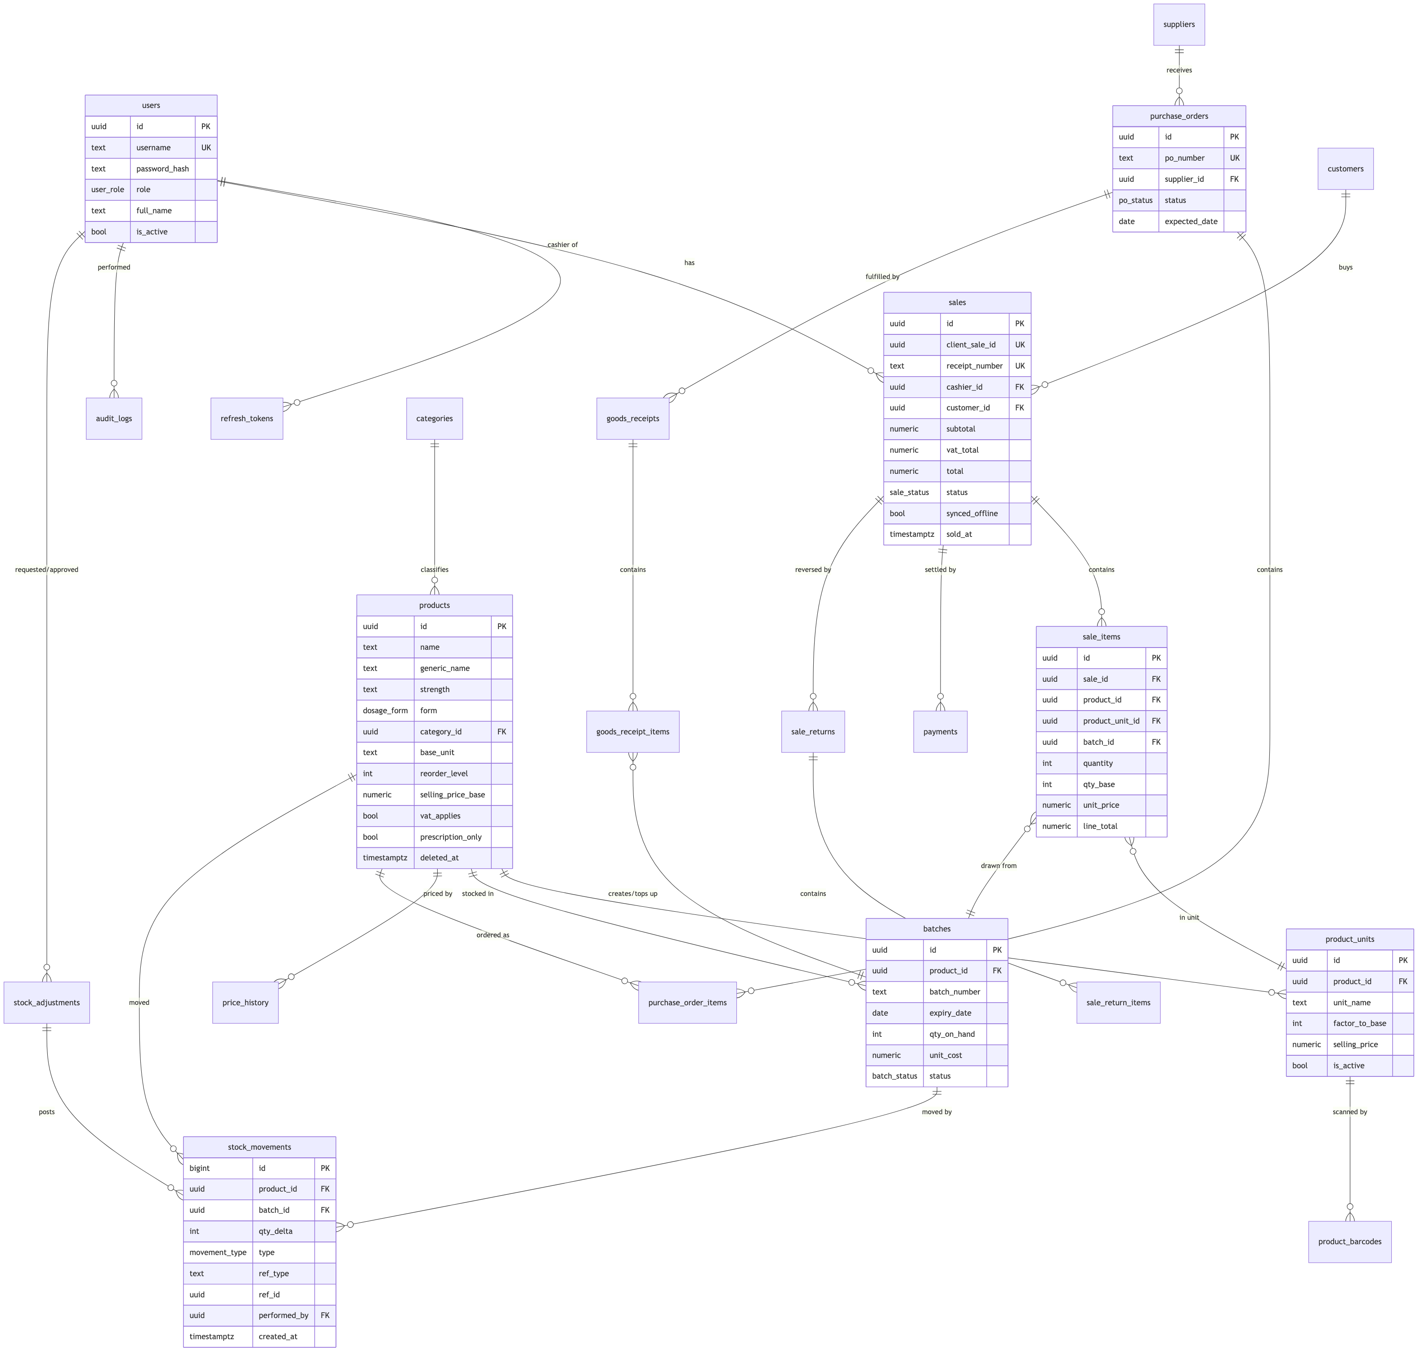
Figure 1
(Attribute lists abbreviated for readability; schema.sql is authoritative and includes payments, customers, suppliers, goods_receipts, stock_adjustments, sale_returns, audit_logs, settings, price_history, refresh_tokens.)

Normalization
The schema is in third normal form (3NF):
- 1NF: no repeating groups — multiple barcodes per product live in product_barcodes rows, not a comma-separated column; multiple pack sizes live in product_units.
- 2NF: every non-key attribute depends on the whole key — e.g., unit_price sits on sale_items (depends on the sale line), not on sales.
- 3NF: no transitive dependencies — supplier contact details live only in suppliers, never copied onto purchase orders; category name only in categories.
Deliberate, documented denormalizations (performance/immutability, each justified):
Field | Why
batches.qty_on_hand | Hot-path read for POS and dashboards; recomputable from stock_movements (invariant checked by a nightly job).
sale_items.unit_price, line_total; sales.total | Point-in-time snapshot: receipts must not change when prices change later (BR-03/BR-04).
stock_movements.qty_delta sign convention | Positive = stock in, negative = stock out; avoids joins to interpret the ledger.

Keys, constraints & integrity highlights
Concern | Mechanism
Primary keys | UUIDv7 app-generated (sortable, offline-safe); stock_movements uses BIGINT IDENTITY (append-only ledger)
No oversell (online) | Batch rows locked FOR UPDATE inside the sale transaction; qty_on_hand may go negative only via the offline-sync path, which flags an exception (ADR-006)
Expired stock unsellable | batches.status derived by nightly job + CHECK (expiry_date > sold-at) enforced in service layer; report view v_expired_stock
Valid money/quantities | CHECK (quantity > 0) on sale/PO/receipt lines; CHECK (factor_to_base >= 1); CHECK (total >= 0)
Duplicate scans | product_barcodes.barcode globally unique
Idempotent offline sync | sales.client_sale_id unique
Referential integrity | FKs everywhere with ON DELETE RESTRICT (history is protected); soft delete instead of row deletion

Indexes (beyond PKs/UKs)
Index | Serves
GIN (name gin_trgm_ops), GIN (generic_name gin_trgm_ops) on products | <300 ms fuzzy search over 10k SKUs (NFR-01)
batches (product_id, expiry_date) WHERE status = 'ACTIVE' | FEFO pick + expiry dashboards
stock_movements (product_id, created_at DESC) | Product movement history
stock_movements (ref_type, ref_id) | Trace a sale/receipt to its ledger entries
sales (sold_at DESC), sales (cashier_id, sold_at) | Z-reports, cashier reports
sale_items (product_id, created_at) | Top-sellers, product sales history
audit_logs (entity, entity_id, created_at DESC) | Entity audit trail

Reporting views
v_stock_on_hand (per product: base-unit qty, unit breakdown, valuation at cost), v_low_stock, v_expiring_batches (30/60/90-day windows), v_expired_stock, v_daily_sales (Z-report source), v_shrinkage (adjustments by reason). Defined in schema.sql §7 — the reporting module reads only these views.

PharmaTrack — Database Schema (PostgreSQL DDL)
COE 454 — Week 3 supplement to the Database Design document. Authoritative DDL; production migrations are generated via Prisma.
-- =============================================================================
-- PharmaTrack — PostgreSQL 16 schema (authoritative DDL)
-- COE 454 Week 3 · Generated as design artifact; production migrations via Prisma
-- Conventions: UUIDv7 PKs (app-generated), money NUMERIC(12,2) GHS,
-- quantities INTEGER in base units, timestamptz everywhere.
-- =============================================================================
CREATE EXTENSION IF NOT EXISTS pg_trgm;
-- ---------- 1. Enums ---------------------------------------------------------
CREATE TYPE user_role AS ENUM ('ADMIN','MANAGER','PHARMACIST','INVENTORY_OFFICER','CASHIER');
CREATE TYPE dosage_form AS ENUM ('TABLET','CAPSULE','SYRUP','SUSPENSION','INJECTION','CREAM','OINTMENT','DROPS','INHALER','SUPPOSITORY','CONSUMABLE','OTHER');
CREATE TYPE batch_status AS ENUM ('ACTIVE','EXPIRED','QUARANTINED','DEPLETED');
CREATE TYPE movement_type AS ENUM ('OPENING','RECEIPT','SALE','RETURN_IN','ADJUSTMENT','DISPOSAL');
CREATE TYPE po_status AS ENUM ('DRAFT','SENT','PARTIALLY_RECEIVED','RECEIVED','CLOSED','CANCELLED');
CREATE TYPE sale_status AS ENUM ('COMPLETED','VOIDED');
CREATE TYPE payment_method AS ENUM ('CASH','MOMO','CARD');
CREATE TYPE adjustment_reason AS ENUM ('DAMAGE','THEFT','COUNT_CORRECTION','EXPIRY_DISPOSAL','SUPPLIER_RETURN','OTHER');
CREATE TYPE adjustment_status AS ENUM ('PENDING_APPROVAL','APPROVED','REJECTED');
-- ---------- 2. People & access ----------------------------------------------
CREATE TABLE users (
id UUID PRIMARY KEY,
username TEXT NOT NULL UNIQUE,
password_hash TEXT NOT NULL, -- argon2id
full_name TEXT NOT NULL,
phone TEXT,
role user_role NOT NULL,
is_active BOOLEAN NOT NULL DEFAULT TRUE,
failed_logins SMALLINT NOT NULL DEFAULT 0,
locked_until TIMESTAMPTZ,
created_at TIMESTAMPTZ NOT NULL DEFAULT now(),
updated_at TIMESTAMPTZ NOT NULL DEFAULT now(),
created_by UUID REFERENCES users(id)
);
CREATE TABLE refresh_tokens (
id UUID PRIMARY KEY,
user_id UUID NOT NULL REFERENCES users(id) ON DELETE CASCADE,
token_hash TEXT NOT NULL UNIQUE, -- sha256 of the token
device_label TEXT,
expires_at TIMESTAMPTZ NOT NULL,
revoked_at TIMESTAMPTZ,
created_at TIMESTAMPTZ NOT NULL DEFAULT now()
);
CREATE INDEX ix_refresh_user ON refresh_tokens (user_id) WHERE revoked_at IS NULL;
-- ---------- 3. Catalogue ------------------------------------------------------
CREATE TABLE categories (
id UUID PRIMARY KEY,
name TEXT NOT NULL UNIQUE, -- Medicines, Cosmetics, Food & Drinks…
created_at TIMESTAMPTZ NOT NULL DEFAULT now(),
updated_at TIMESTAMPTZ NOT NULL DEFAULT now()
);
CREATE TABLE products (
id UUID PRIMARY KEY,
name TEXT NOT NULL, -- brand/display name
generic_name TEXT,
strength TEXT, -- '500 mg', '125 mg/5 ml'
form dosage_form NOT NULL DEFAULT 'OTHER',
category_id UUID NOT NULL REFERENCES categories(id),
base_unit TEXT NOT NULL, -- 'tablet','ml','piece'
selling_price_base NUMERIC(12,2) NOT NULL CHECK (selling_price_base >= 0),
reorder_level INTEGER NOT NULL DEFAULT 0 CHECK (reorder_level >= 0),
vat_applies BOOLEAN NOT NULL DEFAULT FALSE,
prescription_only BOOLEAN NOT NULL DEFAULT FALSE, -- BR-08 flag
notes TEXT,
legacy_item_no TEXT, -- QB POS Item No. (US-16 migration)
deleted_at TIMESTAMPTZ, -- soft delete (US-03 AC3)
created_at TIMESTAMPTZ NOT NULL DEFAULT now(),
updated_at TIMESTAMPTZ NOT NULL DEFAULT now(),
created_by UUID REFERENCES users(id),
updated_by UUID REFERENCES users(id)
);
CREATE INDEX ix_products_name_trgm ON products USING gin (name gin_trgm_ops);
CREATE INDEX ix_products_generic_trgm ON products USING gin (generic_name gin_trgm_ops);
CREATE INDEX ix_products_category ON products (category_id) WHERE deleted_at IS NULL;
CREATE TABLE product_units ( -- US-04 multi-unit packaging
id UUID PRIMARY KEY,
product_id UUID NOT NULL REFERENCES products(id),
unit_name TEXT NOT NULL, -- 'carton','pack','strip','tablet'
factor_to_base INTEGER NOT NULL CHECK (factor_to_base >= 1),
selling_price NUMERIC(12,2) NOT NULL CHECK (selling_price >= 0),
is_active BOOLEAN NOT NULL DEFAULT TRUE, -- retired, never edited (US-04 AC3)
created_at TIMESTAMPTZ NOT NULL DEFAULT now(),
UNIQUE (product_id, unit_name)
);
CREATE TABLE product_barcodes (
id UUID PRIMARY KEY,
product_id UUID NOT NULL REFERENCES products(id),
product_unit_id UUID REFERENCES product_units(id), -- carton barcode ≠ strip barcode
barcode TEXT NOT NULL UNIQUE, -- US-03 AC2
created_at TIMESTAMPTZ NOT NULL DEFAULT now()
);
CREATE TABLE price_history ( -- BR-03 versioned prices
id UUID PRIMARY KEY,
product_id UUID NOT NULL REFERENCES products(id),
product_unit_id UUID REFERENCES product_units(id),
old_price NUMERIC(12,2) NOT NULL,
new_price NUMERIC(12,2) NOT NULL,
changed_by UUID NOT NULL REFERENCES users(id),
effective_from TIMESTAMPTZ NOT NULL DEFAULT now()
);
-- ---------- 4. Suppliers & purchasing ----------------------------------------
CREATE TABLE suppliers (
id UUID PRIMARY KEY,
name TEXT NOT NULL,
contact_name TEXT,
phone TEXT,
email TEXT,
address TEXT,
deleted_at TIMESTAMPTZ,
created_at TIMESTAMPTZ NOT NULL DEFAULT now(),
updated_at TIMESTAMPTZ NOT NULL DEFAULT now(),
created_by UUID REFERENCES users(id)
);
CREATE TABLE purchase_orders (
id UUID PRIMARY KEY,
po_number TEXT NOT NULL UNIQUE, -- 'PO-2026-0001'
supplier_id UUID NOT NULL REFERENCES suppliers(id),
status po_status NOT NULL DEFAULT 'DRAFT',
expected_date DATE,
notes TEXT,
created_at TIMESTAMPTZ NOT NULL DEFAULT now(),
updated_at TIMESTAMPTZ NOT NULL DEFAULT now(),
created_by UUID NOT NULL REFERENCES users(id)
);
CREATE TABLE purchase_order_items (
id UUID PRIMARY KEY,
po_id UUID NOT NULL REFERENCES purchase_orders(id),
product_id UUID NOT NULL REFERENCES products(id),
qty_base INTEGER NOT NULL CHECK (qty_base > 0),
unit_cost NUMERIC(12,4) NOT NULL CHECK (unit_cost >= 0), -- per base unit
qty_received INTEGER NOT NULL DEFAULT 0 CHECK (qty_received >= 0),
UNIQUE (po_id, product_id)
);
CREATE TABLE goods_receipts (
id UUID PRIMARY KEY,
grn_number TEXT NOT NULL UNIQUE, -- 'GRN-2026-0001'
po_id UUID REFERENCES purchase_orders(id), -- nullable: direct receipt
supplier_id UUID NOT NULL REFERENCES suppliers(id),
received_at TIMESTAMPTZ NOT NULL DEFAULT now(),
received_by UUID NOT NULL REFERENCES users(id),
notes TEXT
);
CREATE TABLE goods_receipt_items (
id UUID PRIMARY KEY,
receipt_id UUID NOT NULL REFERENCES goods_receipts(id),
product_id UUID NOT NULL REFERENCES products(id),
batch_id UUID NOT NULL, -- FK added after batches
qty_base INTEGER NOT NULL CHECK (qty_base > 0),
unit_cost NUMERIC(12,4) NOT NULL CHECK (unit_cost >= 0)
);
-- ---------- 5. Inventory ------------------------------------------------------
CREATE TABLE batches ( -- US-05 batch & expiry
id UUID PRIMARY KEY,
product_id UUID NOT NULL REFERENCES products(id),
batch_number TEXT NOT NULL,
expiry_date DATE NOT NULL,
qty_on_hand INTEGER NOT NULL DEFAULT 0, -- may go negative ONLY via offline sync (ADR-006)
unit_cost NUMERIC(12,4) NOT NULL DEFAULT 0, -- weighted average, per base unit
status batch_status NOT NULL DEFAULT 'ACTIVE',
created_at TIMESTAMPTZ NOT NULL DEFAULT now(),
updated_at TIMESTAMPTZ NOT NULL DEFAULT now(),
UNIQUE (product_id, batch_number, expiry_date)
);
CREATE INDEX ix_batches_fefo ON batches (product_id, expiry_date) WHERE status = 'ACTIVE';
ALTER TABLE goods_receipt_items
ADD CONSTRAINT fk_gri_batch FOREIGN KEY (batch_id) REFERENCES batches(id);
CREATE TABLE stock_adjustments ( -- US-12
id UUID PRIMARY KEY,
product_id UUID NOT NULL REFERENCES products(id),
batch_id UUID NOT NULL REFERENCES batches(id),
qty_delta INTEGER NOT NULL CHECK (qty_delta <> 0),
reason adjustment_reason NOT NULL,
note TEXT,
status adjustment_status NOT NULL DEFAULT 'PENDING_APPROVAL',
requested_by UUID NOT NULL REFERENCES users(id),
approved_by UUID REFERENCES users(id),
decided_at TIMESTAMPTZ,
created_at TIMESTAMPTZ NOT NULL DEFAULT now(),
CHECK (status <> 'APPROVED' OR approved_by IS NOT NULL)
);
CREATE TABLE stock_movements ( -- append-only ledger; NEVER updated
id BIGINT GENERATED ALWAYS AS IDENTITY PRIMARY KEY,
product_id UUID NOT NULL REFERENCES products(id),
batch_id UUID NOT NULL REFERENCES batches(id),
qty_delta INTEGER NOT NULL CHECK (qty_delta <> 0), -- + in, − out (base units)
type movement_type NOT NULL,
ref_type TEXT NOT NULL, -- 'sale','goods_receipt','stock_adjustment','sale_return'
ref_id UUID NOT NULL,
unit_cost NUMERIC(12,4) NOT NULL DEFAULT 0, -- cost snapshot at movement time
performed_by UUID NOT NULL REFERENCES users(id),
created_at TIMESTAMPTZ NOT NULL DEFAULT now()
);
CREATE INDEX ix_mov_product ON stock_movements (product_id, created_at DESC);
CREATE INDEX ix_mov_ref ON stock_movements (ref_type, ref_id);
-- ---------- 6. Customers & sales ----------------------------------------------
CREATE TABLE customers (
id UUID PRIMARY KEY,
full_name TEXT NOT NULL,
phone TEXT UNIQUE,
notes TEXT, -- access: PHARMACIST+ (US-15/Act 843)
deleted_at TIMESTAMPTZ,
created_at TIMESTAMPTZ NOT NULL DEFAULT now(),
updated_at TIMESTAMPTZ NOT NULL DEFAULT now()
);
CREATE TABLE sales (
id UUID PRIMARY KEY,
client_sale_id UUID NOT NULL UNIQUE, -- idempotent offline sync (ADR-006)
receipt_number TEXT NOT NULL UNIQUE, -- 'RCP-2026-000123', server-assigned
cashier_id UUID NOT NULL REFERENCES users(id),
customer_id UUID REFERENCES customers(id),
subtotal NUMERIC(12,2) NOT NULL CHECK (subtotal >= 0),
discount_total NUMERIC(12,2) NOT NULL DEFAULT 0 CHECK (discount_total >= 0),
vat_total NUMERIC(12,2) NOT NULL DEFAULT 0 CHECK (vat_total >= 0),
total NUMERIC(12,2) NOT NULL CHECK (total >= 0),
status sale_status NOT NULL DEFAULT 'COMPLETED',
synced_offline BOOLEAN NOT NULL DEFAULT FALSE, -- true if arrived via sync queue
sold_at TIMESTAMPTZ NOT NULL, -- client timestamp (offline-true)
created_at TIMESTAMPTZ NOT NULL DEFAULT now() -- server receive time
);
CREATE INDEX ix_sales_sold_at ON sales (sold_at DESC);
CREATE INDEX ix_sales_cashier ON sales (cashier_id, sold_at DESC);
CREATE TABLE sale_items (
id UUID PRIMARY KEY,
sale_id UUID NOT NULL REFERENCES sales(id),
product_id UUID NOT NULL REFERENCES products(id),
product_unit_id UUID REFERENCES product_units(id), -- null ⇒ base unit
batch_id UUID NOT NULL REFERENCES batches(id),
quantity INTEGER NOT NULL CHECK (quantity > 0), -- in the sold unit
qty_base INTEGER NOT NULL CHECK (qty_base > 0), -- converted snapshot
unit_price NUMERIC(12,2) NOT NULL CHECK (unit_price >= 0), -- snapshot
discount NUMERIC(12,2) NOT NULL DEFAULT 0 CHECK (discount >= 0),
line_total NUMERIC(12,2) NOT NULL CHECK (line_total >= 0),
created_at TIMESTAMPTZ NOT NULL DEFAULT now()
);
CREATE INDEX ix_sale_items_sale ON sale_items (sale_id);
CREATE INDEX ix_sale_items_product ON sale_items (product_id, created_at);
CREATE TABLE payments (
id UUID PRIMARY KEY,
sale_id UUID NOT NULL REFERENCES sales(id),
method payment_method NOT NULL,
amount NUMERIC(12,2) NOT NULL CHECK (amount > 0),
tendered NUMERIC(12,2),
change_due NUMERIC(12,2),
momo_ref TEXT,
created_at TIMESTAMPTZ NOT NULL DEFAULT now()
);
CREATE TABLE sale_returns ( -- US-14
id UUID PRIMARY KEY,
sale_id UUID NOT NULL REFERENCES sales(id),
reason TEXT NOT NULL,
refund_total NUMERIC(12,2) NOT NULL CHECK (refund_total >= 0),
approved_by UUID NOT NULL REFERENCES users(id), -- PHARMACIST/MANAGER (AC2)
processed_by UUID NOT NULL REFERENCES users(id),
created_at TIMESTAMPTZ NOT NULL DEFAULT now()
);
CREATE TABLE sale_return_items (
id UUID PRIMARY KEY,
sale_return_id UUID NOT NULL REFERENCES sale_returns(id),
sale_item_id UUID NOT NULL REFERENCES sale_items(id),
qty_base INTEGER NOT NULL CHECK (qty_base > 0),
restock BOOLEAN NOT NULL DEFAULT TRUE -- false ⇒ disposal adjustment
);
-- ---------- 7. Cross-cutting ---------------------------------------------------
CREATE TABLE audit_logs (
id BIGINT GENERATED ALWAYS AS IDENTITY PRIMARY KEY,
user_id UUID REFERENCES users(id),
action TEXT NOT NULL, -- 'sale.void','product.price_change','auth.lockout'…
entity TEXT NOT NULL,
entity_id TEXT NOT NULL,
before JSONB,
after JSONB,
ip_address INET,
created_at TIMESTAMPTZ NOT NULL DEFAULT now()
);
CREATE INDEX ix_audit_entity ON audit_logs (entity, entity_id, created_at DESC);
CREATE TABLE settings (
key TEXT PRIMARY KEY, -- 'vat_rate','expiry_warn_days','adjust_approval_threshold','receipt_header'
value JSONB NOT NULL,
updated_by UUID REFERENCES users(id),
updated_at TIMESTAMPTZ NOT NULL DEFAULT now()
);
CREATE TABLE notifications (
id UUID PRIMARY KEY,
type TEXT NOT NULL, -- 'LOW_STOCK','EXPIRY_90','EXPIRED','NEG_STOCK_EXCEPTION'
payload JSONB NOT NULL,
seen_at TIMESTAMPTZ,
created_at TIMESTAMPTZ NOT NULL DEFAULT now()
);
-- ---------- 8. Reporting views ---------------------------------------------------
CREATE VIEW v_stock_on_hand AS
SELECT p.id AS product_id, p.name, p.base_unit,
COALESCE(SUM(b.qty_on_hand) FILTER (WHERE b.status = 'ACTIVE'), 0) AS qty_base,
COALESCE(SUM(b.qty_on_hand * b.unit_cost) FILTER (WHERE b.status = 'ACTIVE'), 0)::numeric(14,2) AS value_at_cost,
p.reorder_level
FROM products p LEFT JOIN batches b ON b.product_id = p.id
WHERE p.deleted_at IS NULL
GROUP BY p.id;
CREATE VIEW v_low_stock AS
SELECT * FROM v_stock_on_hand WHERE qty_base <= reorder_level;
CREATE VIEW v_expiring_batches AS
SELECT b.*, p.name AS product_name,
(b.expiry_date - CURRENT_DATE) AS days_to_expiry,
(b.qty_on_hand * b.unit_cost)::numeric(14,2) AS value_at_risk
FROM batches b JOIN products p ON p.id = b.product_id
WHERE b.status = 'ACTIVE' AND b.qty_on_hand > 0
AND b.expiry_date <= CURRENT_DATE + INTERVAL '90 days';
CREATE VIEW v_daily_sales AS
SELECT sold_at::date AS day, COUNT(*) AS receipts,
SUM(total) AS gross, SUM(vat_total) AS vat, SUM(discount_total) AS discounts
FROM sales WHERE status = 'COMPLETED'
GROUP BY sold_at::date;
CREATE VIEW v_shrinkage AS
SELECT sa.reason, COUNT(*) AS adjustments, SUM(sa.qty_delta) AS qty_base,
SUM(sa.qty_delta * b.unit_cost)::numeric(14,2) AS value
FROM stock_adjustments sa JOIN batches b ON b.id = sa.batch_id
WHERE sa.status = 'APPROVED' AND sa.qty_delta < 0
GROUP BY sa.reason;

API Schema
COE 454 — Week 3 Deliverable 3 · REST over HTTPS · Base path /api/v1 Owner: Backend Lead

Conventions
- Auth: Authorization: Bearer <access JWT> on everything except POST /auth/login and POST /auth/refresh. Role requirements listed per endpoint (A=Admin, M=Manager, P=Pharmacist, I=Inventory Officer, C=Cashier; “M+” means M or A).
- Envelope: success → resource or { "data": [...], "meta": { "page", "pageSize", "total" } }; error → { "error": { "code": "BATCH_EXPIRED", "message": "…", "details": {} } } with proper HTTP status (400 validation, 401 auth, 403 role, 404, 409 conflict, 422 domain rule).
- Lists: ?page=&pageSize=&q=&sort= standard; all lists paginated.
- IDs: UUIDs generated client-side where offline matters (sales), server-side otherwise.
- Validation: every body validated by DTO (class-validator); unknown fields rejected.

auth module
Method & path | Roles | Request body | Response
POST /auth/login | public | { username, password } | 200 { accessToken, refreshToken, user: { id, fullName, role } } · 423 when locked
POST /auth/refresh | public | { refreshToken } | 200 { accessToken, refreshToken } (rotated)
POST /auth/logout | any | { refreshToken } | 204 (token revoked)
GET /auth/me | any | — | 200 { id, username, fullName, role }

users module
Method & path | Roles | Request body | Response
GET /users | A, M | — | 200 { data: [User], meta }
POST /users | A | { username, fullName, phone?, role, password } | 201 User
PATCH /users/:id | A | any of { fullName, phone, role, isActive } | 200 User
POST /users/:id/reset-password | A | { newPassword } | 204

catalog module
Method & path | Roles | Request body | Response
GET /products | any | ?q= (name/generic/barcode) &categoryId=&lowStock= | 200 { data: [ProductSummary], meta } — <300 ms target
GET /products/:id | any | — | 200 Product (incl. units, barcodes, stock breakdown)
POST /products | I, M+ | { name, genericName?, strength?, form, categoryId, baseUnit, sellingPriceBase, reorderLevel, vatApplies, prescriptionOnly, units?: [{unitName, factorToBase, sellingPrice}], barcodes?: [string] } | 201 Product · 409 duplicate barcode
PATCH /products/:id | I, M+ | subset of above (price changes M+ only → price_history) | 200 Product
DELETE /products/:id | M+ | — | 204 (soft delete)
POST /products/:id/units | M+ | { unitName, factorToBase, sellingPrice } | 201 ProductUnit
POST /products/import | A | multipart CSV (QB export) | 200 { imported, skipped, errors: [{row, message}] } (US-16)
GET /categories / POST /categories | any / M+ | { name } | 200 [Category] / 201 Category
GET /barcodes/:code | any | — | 200 { product, unit } · 404 → POS prompts search (US-06 AC1)

inventory module
Method & path | Roles | Request body | Response
GET /batches | any | ?productId=&expiringWithinDays=&status= | 200 { data: [Batch], meta }
GET /inventory/stock | any | ?lowStock=true | 200 [ { productId, name, qtyBase, unitBreakdown, valueAtCost, reorderLevel } ]
POST /adjustments | I, P, M+ | { productId, batchId, qtyDelta, reason, note? } | 201 Adjustment (status per threshold — BR-05)
POST /adjustments/:id/approve | M+ | { decision: "APPROVED"\|"REJECTED", note? } | 200 Adjustment (approval posts movement)
GET /adjustments | M+ | ?status= | 200 { data, meta }
GET /inventory/movements | M+ | ?productId=&from=&to=&type= | 200 { data: [Movement], meta }

suppliers & purchasing modules
Method & path | Roles | Request body | Response
GET /suppliers / POST /suppliers | I, M+ | { name, contactName?, phone?, email?, address? } | 200/201
PATCH /suppliers/:id / DELETE | I, M+ / M+ | subset | 200 / 204 (soft)
GET /purchase-orders | I, M+ | ?status=&supplierId= | 200 { data, meta }
POST /purchase-orders | I, M+ | { supplierId, expectedDate?, items: [{productId, qtyBase, unitCost}], notes? } | 201 PO (status DRAFT)
POST /purchase-orders/:id/send | I, M+ | — | 200 PO (→ SENT)
POST /purchase-orders/from-suggestions | I, M+ | { productIds: [] } | 201 PO draft from low-stock list (US-10 AC2)
POST /goods-receipts | I, M+ | { poId?, supplierId, items: [{productId, qtyBase, unitCost, batchNumber, expiryDate}], notes? } | 201 GRN — creates/updates batches + RECEIPT movements atomically · 422 OVER_RECEIPT without Manager approval flag (US-09 AC2)
GET /goods-receipts | I, M+ | ?poId= | 200 { data, meta }

sales module (POS + offline sync)
Method & path | Roles | Request body | Response
POST /sales | C, P, M+ | SaleCreate (below) | 201 Sale (receipt number assigned) · 409 duplicate clientSaleId returns the existing sale · 422 BATCH_EXPIRED
POST /sync/sales | C, P, M+ | { sales: [SaleCreate, …] } (queued offline) | 200 { results: [{clientSaleId, status: "created"\|"duplicate"\|"error", receiptNumber?, error?}] } — idempotent (ADR-006)
GET /sales | P, M+ (C: own, today) | ?from=&to=&cashierId=&q=receiptNo | 200 { data, meta }
GET /sales/:id | as above | — | 200 Sale (full lines + payments)
GET /sales/:id/receipt | as above | — | 200 print-ready payload (reprint flagged — US-07 AC2)
POST /sales/:id/void | M+ | { reason } | 200 Sale (compensating movements, audited)
POST /returns | C, P (approval P/M — US-14) | { saleId, items: [{saleItemId, qtyBase, restock}], reason, approverPin } | 201 Return
GET /catalog/snapshot | any | ?since= | 200 { products, units, barcodes, openBatches, version } — offline cache feed
// SaleCreate
{
"clientSaleId": "0198a7ff-…", // UUIDv7, generated at the till
"soldAt": "2026-07-13T18:42:10Z", // client clock (offline-true)
"customerId": null,
"items": [
{ "productId": "…", "productUnitId": "…", "quantity": 2,
"unitPrice": 5.00, "discount": 0 } // batch chosen server-side by FEFO
],
"payments": [ { "method": "CASH", "amount": 28.00, "tendered": 30.00 } ]
}

customers module
Method & path | Roles | Request body | Response
GET /customers / POST /customers | P, M+ | { fullName, phone? } | 200/201
GET /customers/:id/history | P, M+ | — | 200 { data: [SaleSummary], meta }

reporting module (reads views only)
Method & path | Roles | Response
GET /reports/daily?date= | M+ (Z-report), C (own till) | 200 { gross, receipts, byMethod, byCashier, vat, refunds }
GET /reports/sales?from=&to=&groupBy=product\|category\|day | M+ | 200 { rows }
GET /reports/stock-valuation | M+ | 200 { rows, totalValue }
GET /reports/expiring?window=30\|60\|90 | P, M+ | 200 { rows, valueAtRisk }
GET /reports/shrinkage?from=&to= | M+ | 200 { rows }
GET /reports/:name/export?format=csv\|pdf | M+ | 200 file stream (US-13 AC3)

notifications, audit, settings
Method & path | Roles | Request/response
GET /notifications | M+, P | 200 { data: [{id, type, payload, seenAt}] }
POST /notifications/:id/seen | M+, P | 204
GET /audit-logs | A, M | ?entity=&entityId=&userId=&from=&to= → 200 { data, meta }
GET /settings / PATCH /settings | A | { key: value, … } → 200 (each change audited)
GET /health | public | 200 { status: "ok", db: "ok", version } — uptime checks & Week 7 load test

Cross-cutting behaviors
- Idempotency: POST /sales and POST /sync/sales are idempotent on clientSaleId; retries are safe by design.
- Transactions: sale creation = one DB transaction: FEFO batch selection with FOR UPDATE → movements → batch totals → sale + items + payments (NFR-05).
- Audit interceptor: mutating endpoints emit audit entries with before/after diffs.
- Rate limits: /auth/login 5/min/IP (US-01 AC2); global 100 req/min/user.
- Scheduled jobs: nightly batch-status sweep (expired → EXPIRED, notify); 15-min low-stock scan → notifications; Week 5 adds SMS digest via Africa’s Talking.

Analysis & Design Models
SRS supplements — use cases, activity, context/DFD, architecture, class & sequence models. All diagrams are Mermaid (GitHub renders natively). IDs cross-reference the user stories (US-xx) in the Requirements Document.

1. Use case diagram
Split into two views for readability (a single diagram with 15 use cases is unreadable on a page). Role inheritance: Manager can do everything a Pharmacist/Inventory Officer can; Admin can do everything (permission matrix in ADR-005).
(a) POS & sales operations
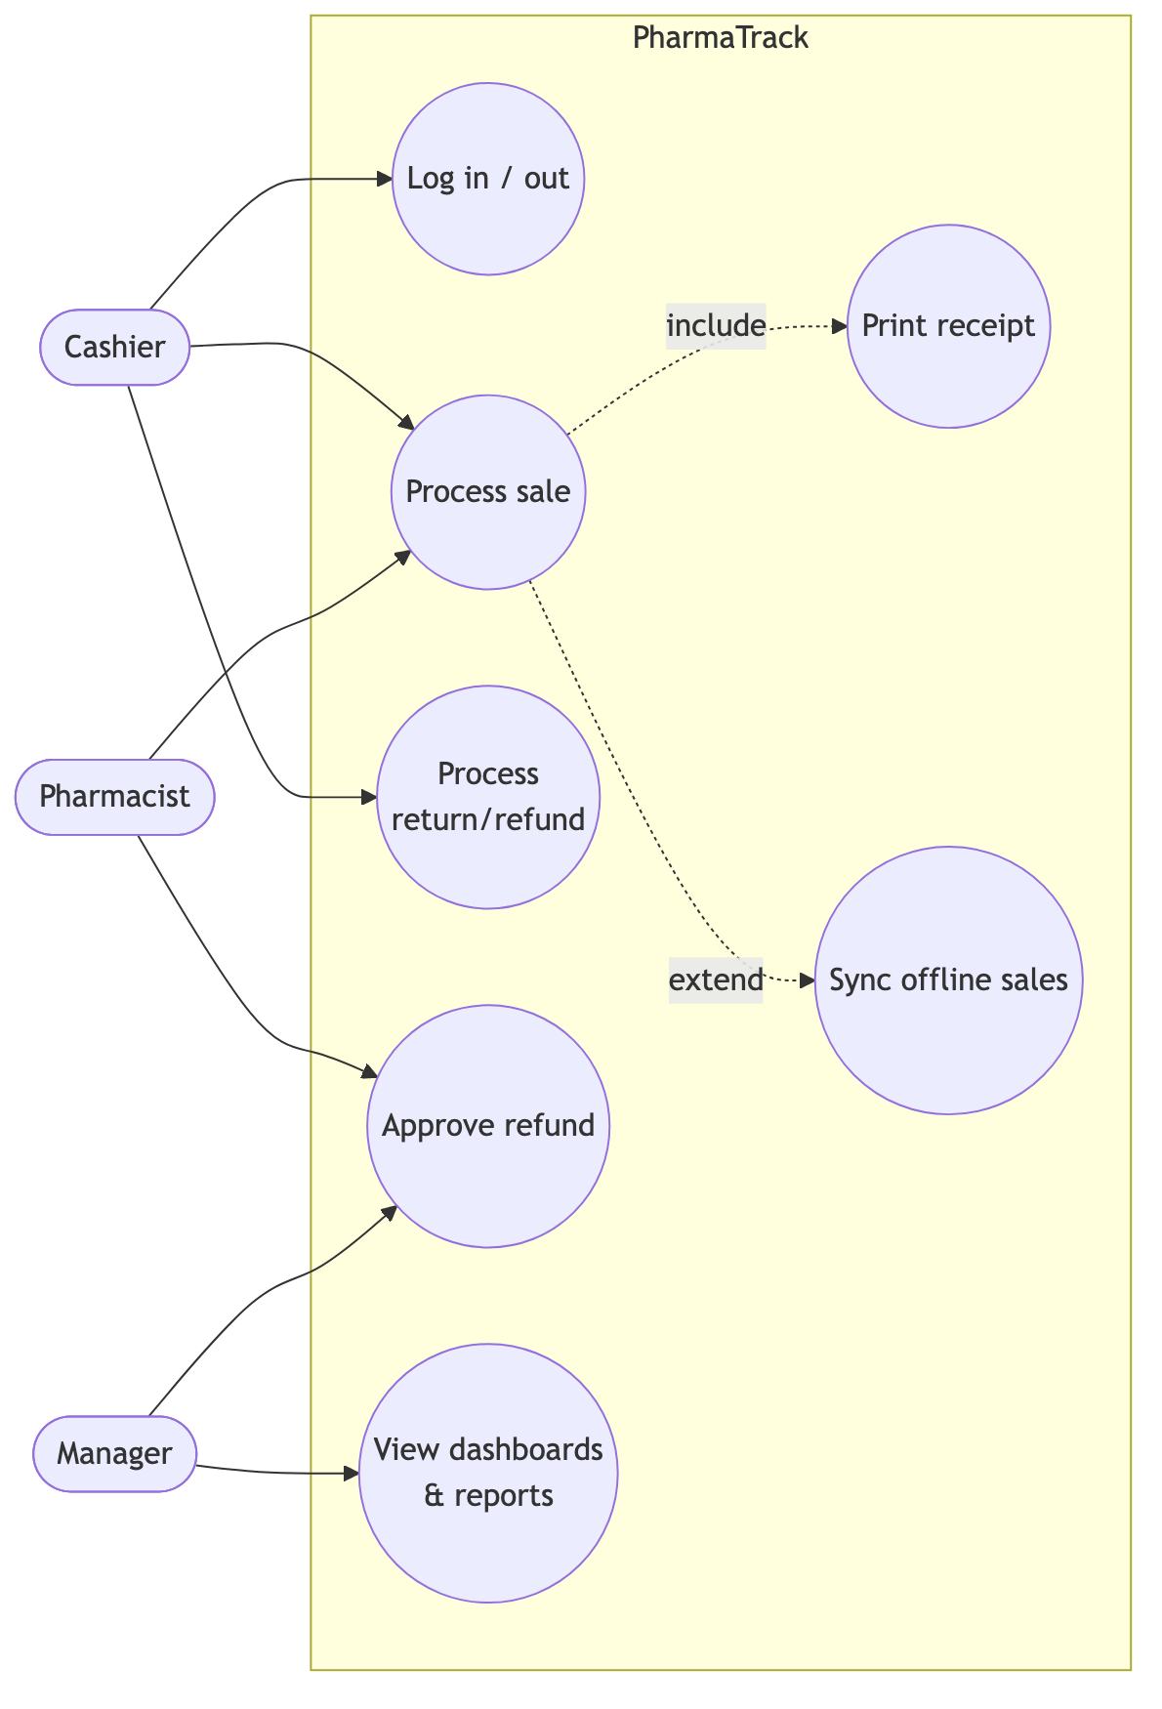
Figure 1
(b) Inventory, purchasing & administration
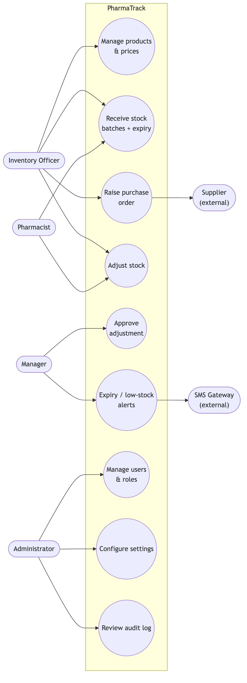
Figure 2

2. Use case descriptions (5 primary)

UC-2 Process sale (US-04/05/06/07/08)
Field | Description
Actors | Cashier (primary), Customer (off-stage)
Preconditions | Cashier authenticated; catalogue cached locally
Main flow | 1. Cashier scans item (or searches by name/generic). 2. System adds line, showing unit options (carton/pack/strip/tablet) and FEFO batch availability. 3. Repeat for all items. 4. Cashier presses F4; enters tendered amount and method. 5. System validates stock atomically, records sale + movements, assigns receipt number. 6. Receipt prints; change displayed.
Alternate flows | A1 unknown barcode → search prompt. A2 offline → sale queued locally with client ID; receipt prints with local number; syncs on reconnect (UC-4). A3 insufficient stock → line blocked with on-hand shown. A4 expired batch only → sale blocked (BR-02).
Postconditions | Stock reduced by movements; immutable sale record; audit trail

UC-7 Receive stock (US-05/09)
Field | Description
Actors | Inventory Officer (primary), Manager (over-receipt approval)
Preconditions | PO exists (or direct receipt allowed); supplier registered
Main flow | 1. Officer opens PO, enters per line: qty received, batch number, expiry date. 2. System validates (expiry > today; qty ≤ outstanding). 3. Officer posts. 4. System creates GRN, creates/tops up batches, writes RECEIPT movements, recalculates weighted-average cost, updates PO status.
Alternate flows | A1 over-receipt → Manager PIN required. A2 partial delivery → PO → PARTIALLY_RECEIVED. A3 short expiry (<90 d) → warning requiring confirmation.
Postconditions | Sellable stock available to POS with correct expiry ordering

UC-9 Adjust stock (US-12)
Actors: any stock role requests; Manager approves above threshold (BR-05). Main flow: select product+batch → qty delta + reason + note → if |value| > threshold, status PENDING_APPROVAL → Manager approves → ADJUSTMENT movement posts. Rejected adjustments post nothing. All paths audited; shrinkage reportable by reason.

UC-4 Sync offline sales (US-08)
Actor: system (background). Trigger: connectivity restored. Flow: queued sales POSTed in order to /sync/sales → server creates each idempotently on clientSaleId → FEFO deduction at sync time → response marks created/duplicate/error → till clears queue, updates badge. Exception: batch oversold during outage → sale recorded, negative-stock exception notification to Manager (ADR-006).

UC-11 View reports (US-13)
Actor: Manager/Owner. Flow: pick report + date range → server reads reporting views → render table + chart → optional CSV/PDF export. Z-report closes the trading day.

3. Activity diagram — Process sale (with offline branch)
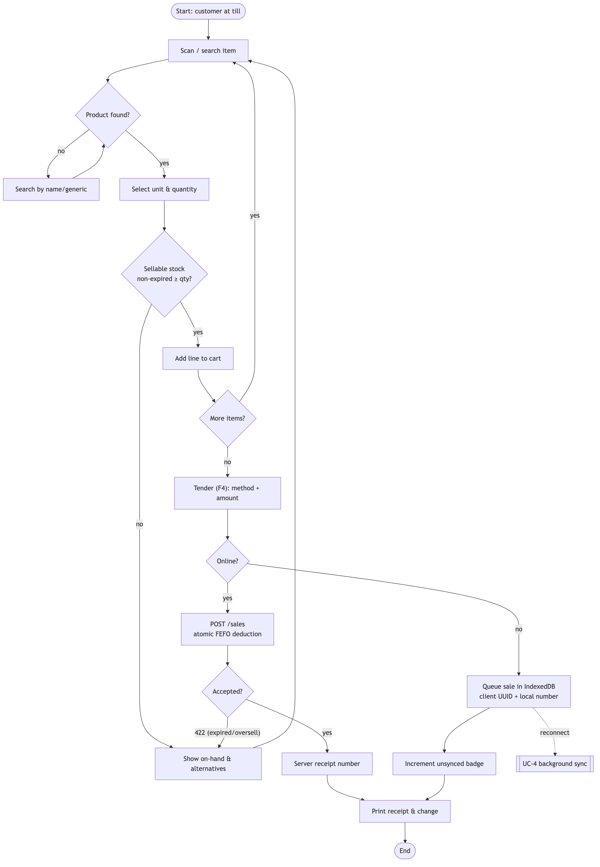
Figure 3

4. Activity diagram — Receive purchase order
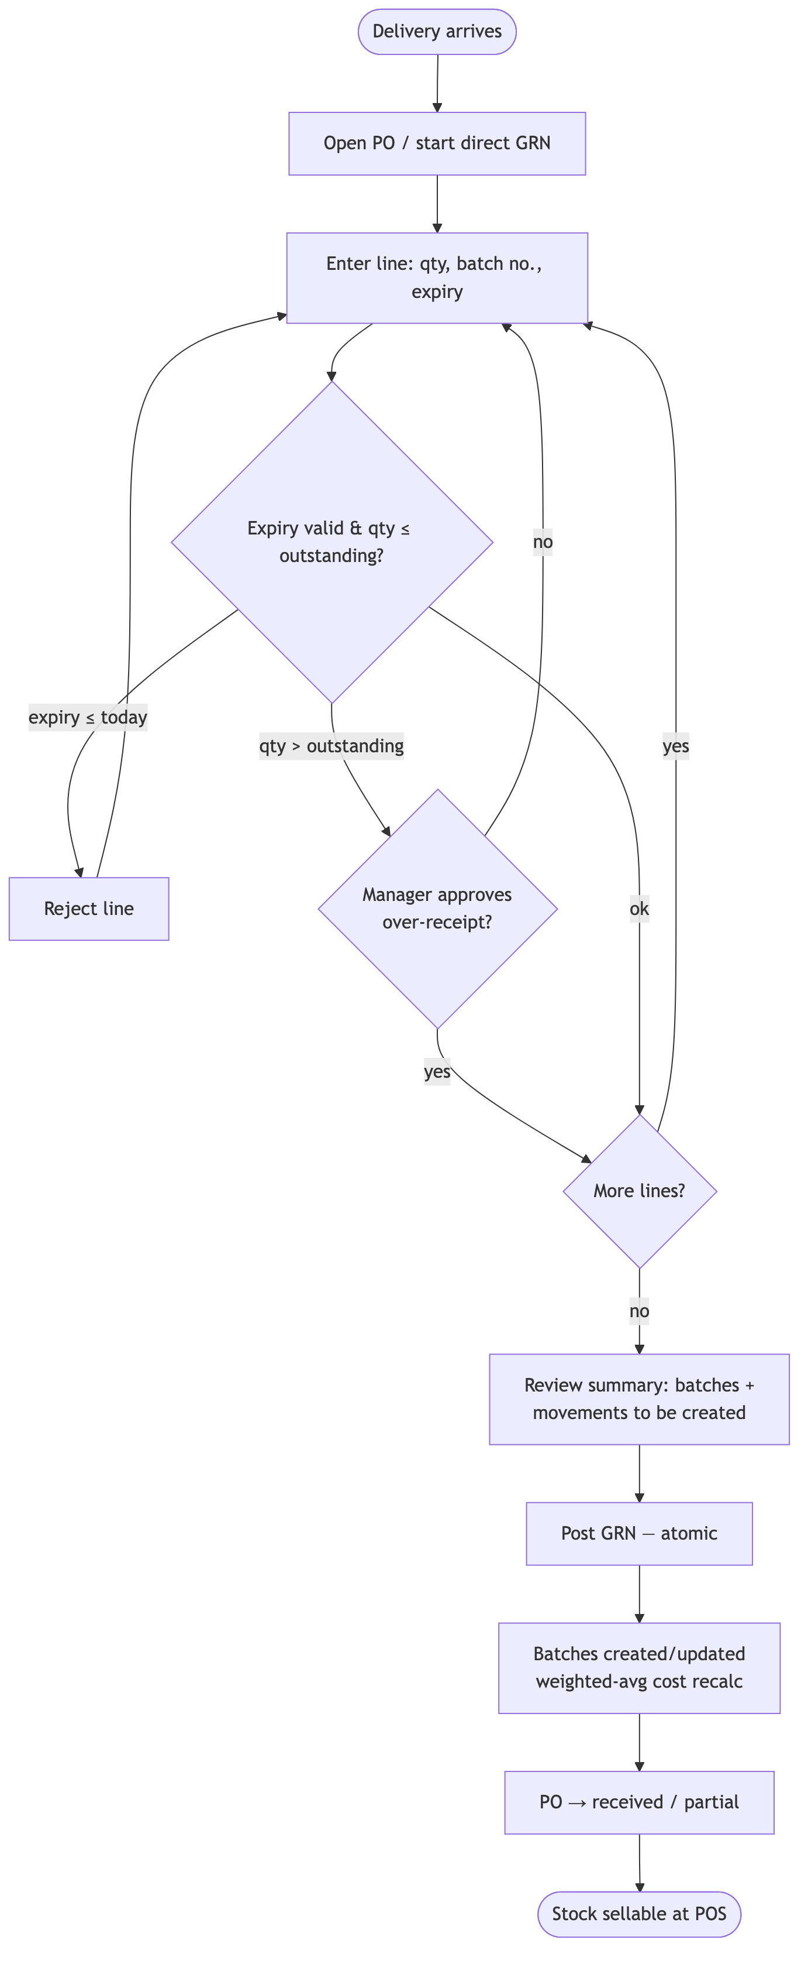
Figure 4

5. Context diagram (Level 0 system boundary)
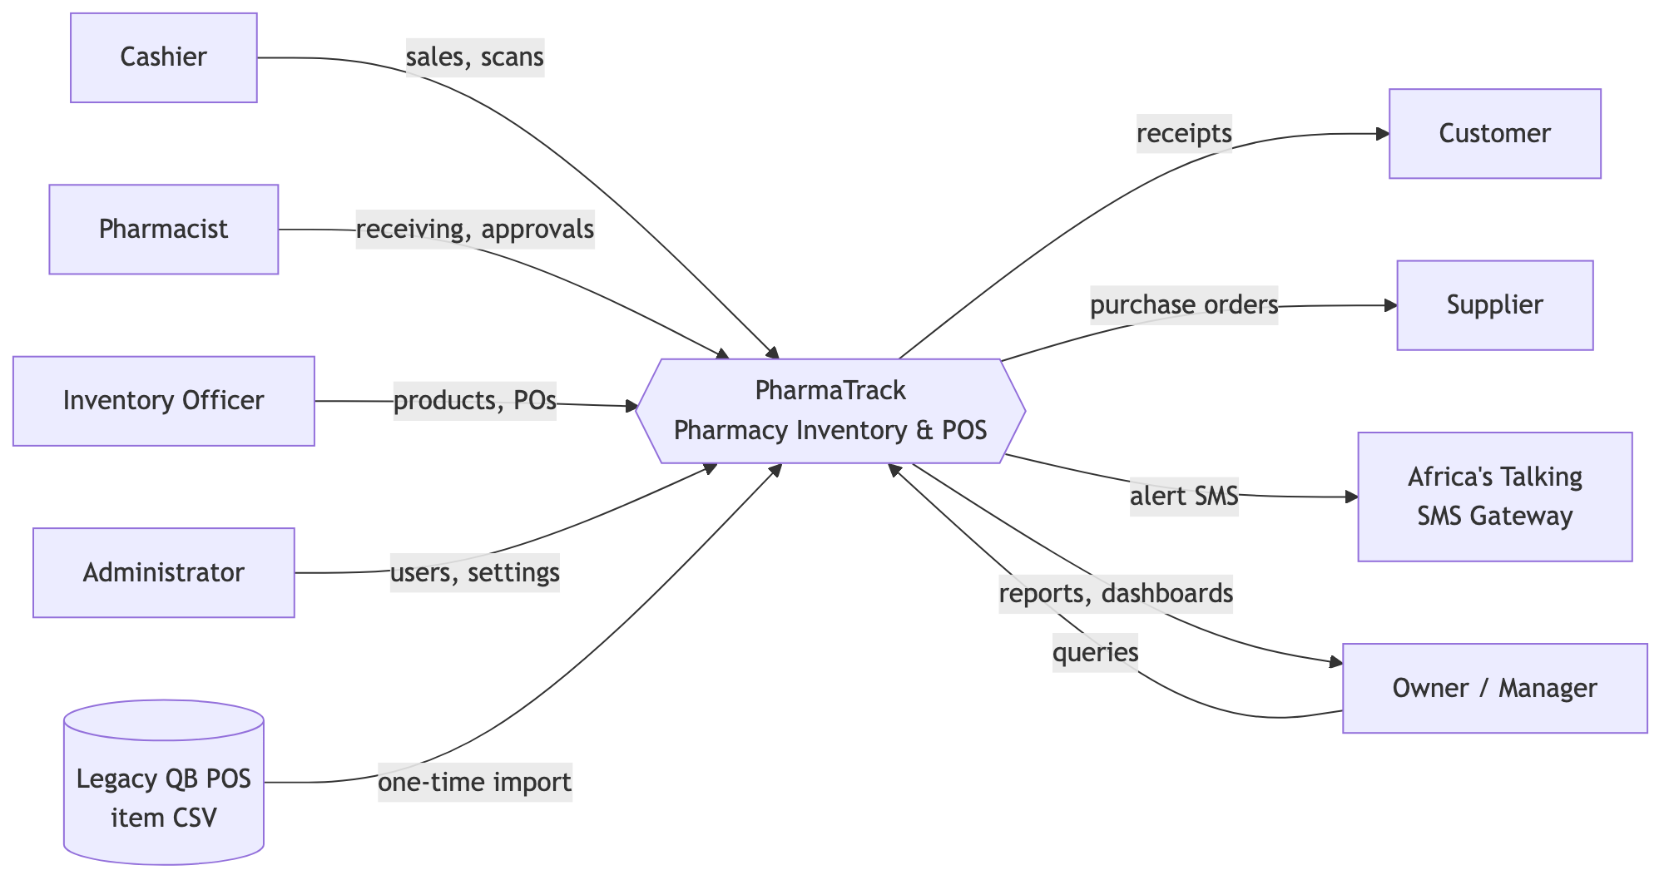
Figure 5

6. Data flow diagram — Level 0
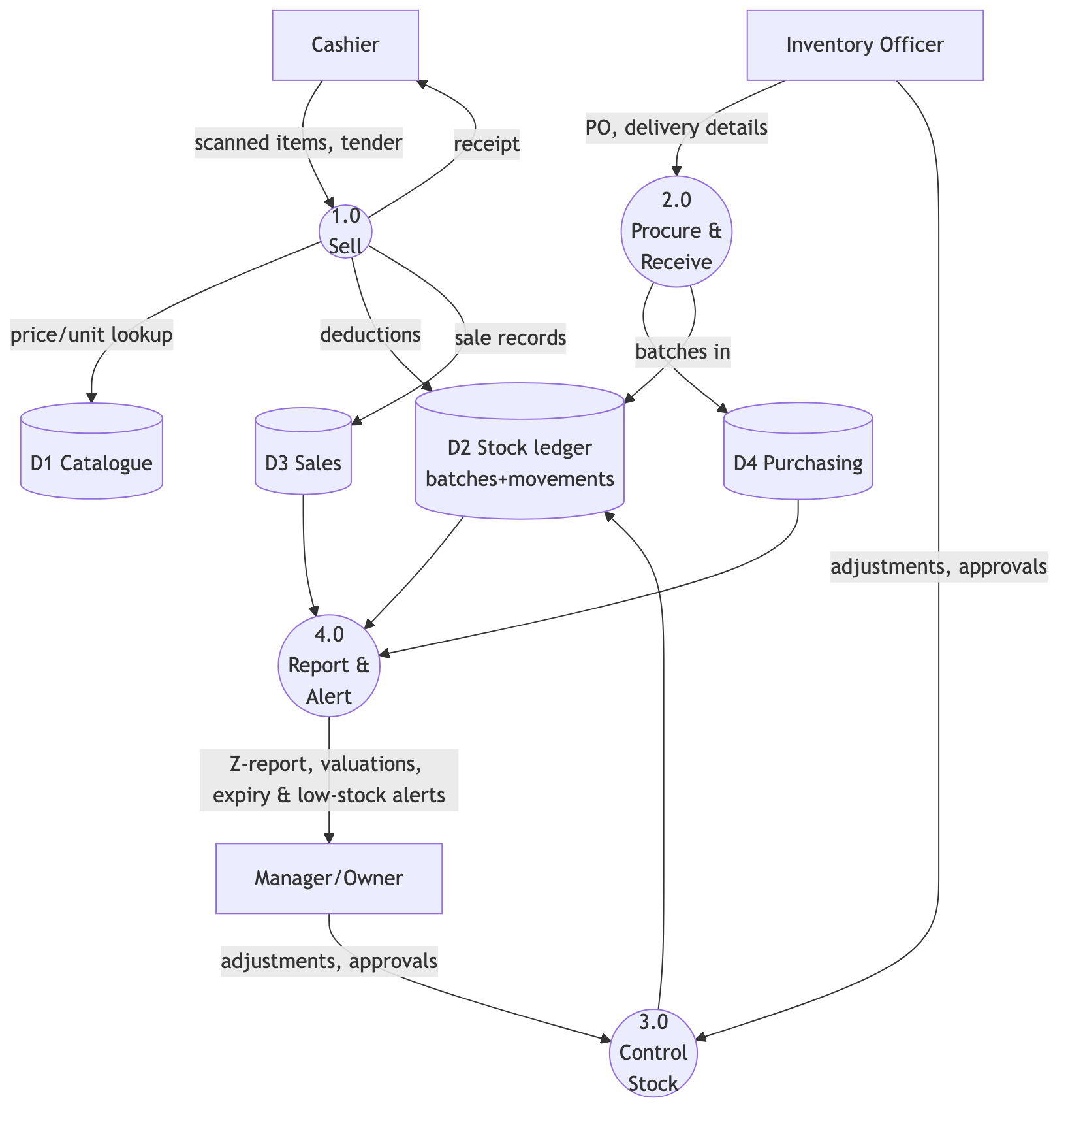
Figure 6

7. Data flow diagram — Level 1 of process 1.0 (Sell)
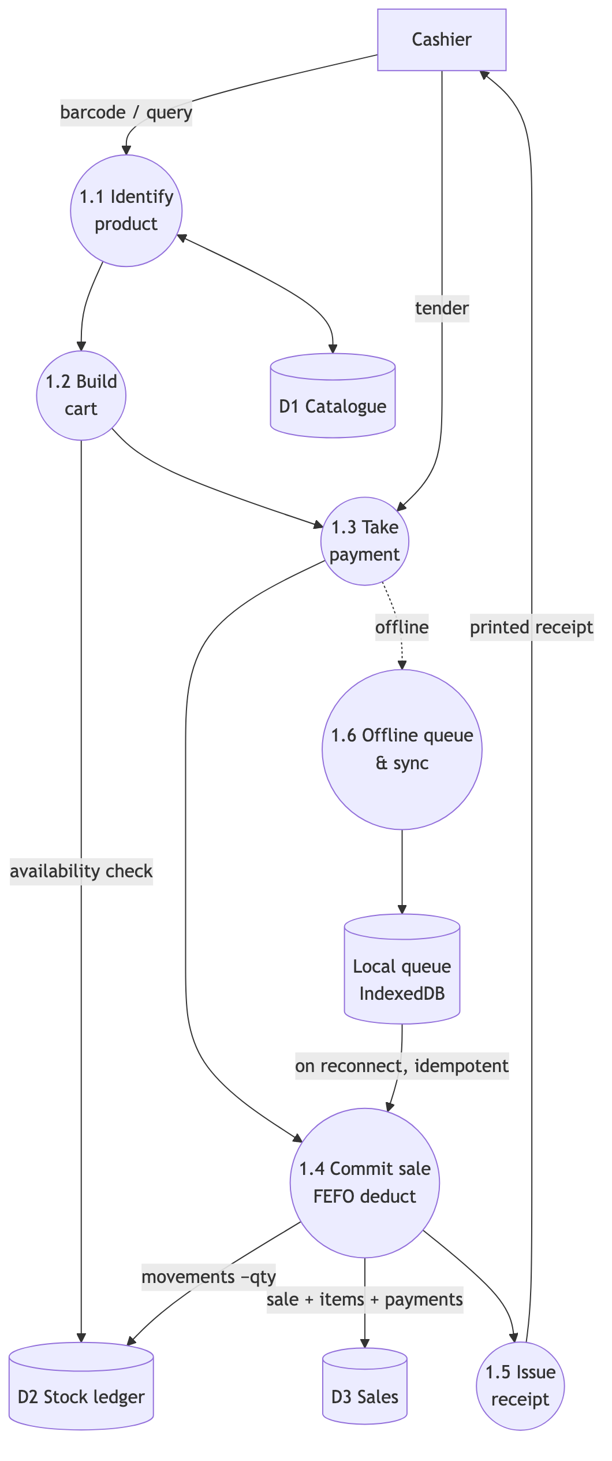
Figure 7

8. System architecture diagram
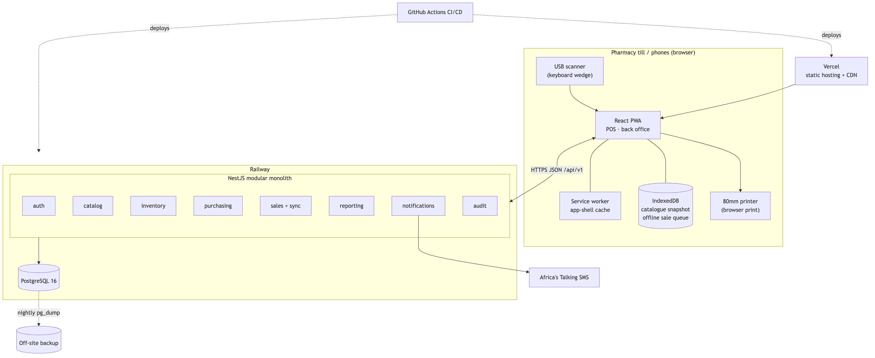
Figure 8
Module diagram: see the dependency table in ADR-001; arrows inside api are enforced by lint rules — sales → catalog/inventory/customers, purchasing → suppliers/catalog/ inventory, audit subscribes to events from all, reporting reads views only.

9. Class diagram (domain layer, key types)
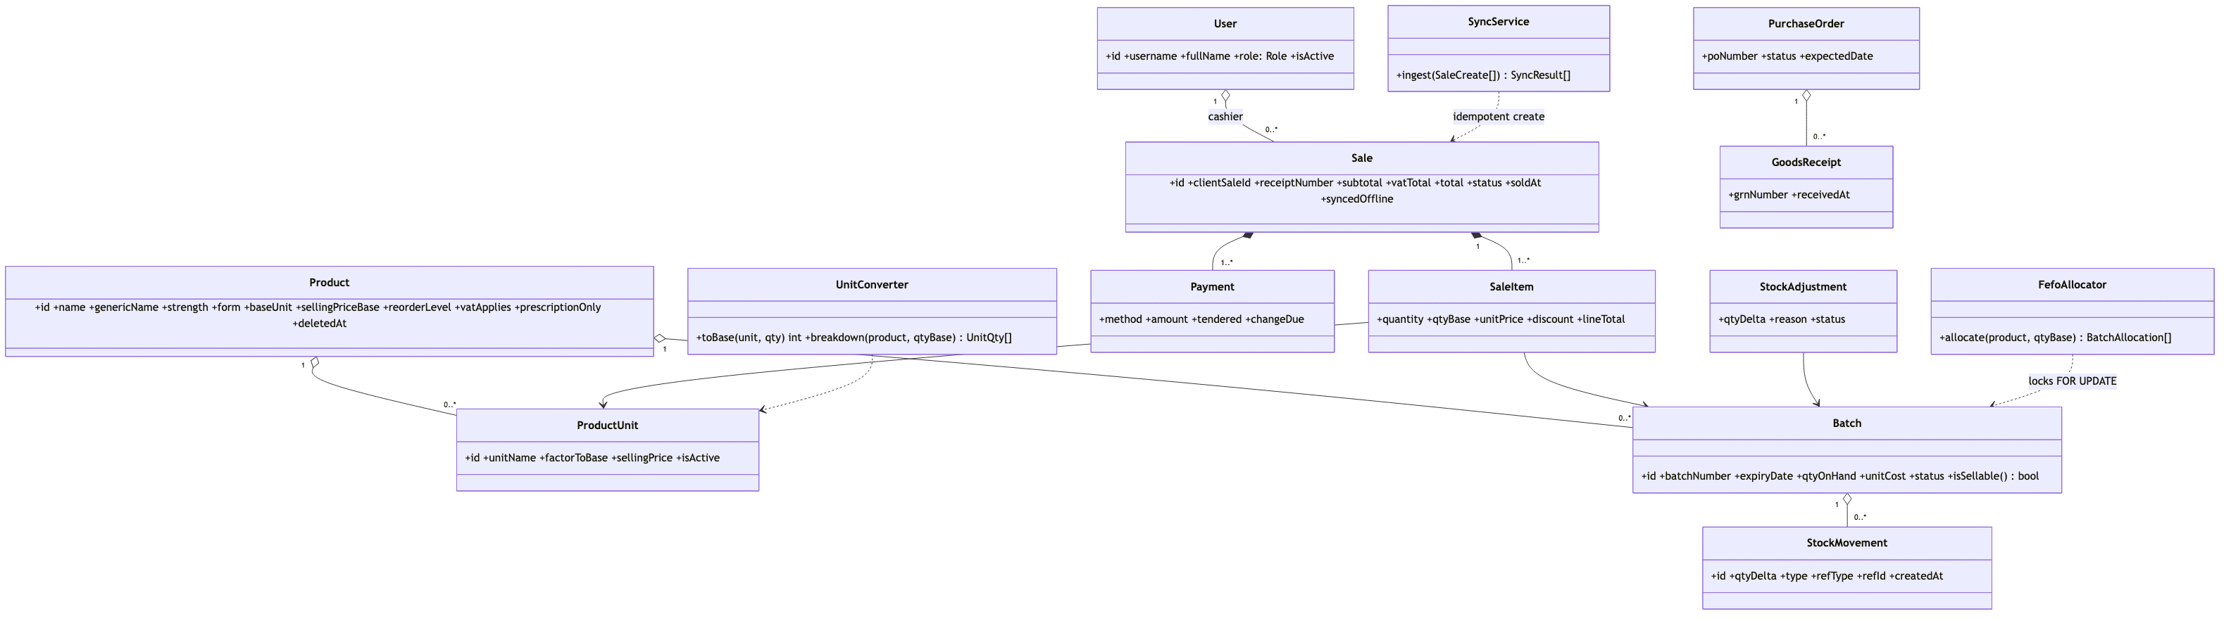
Figure 9

10. Sequence diagram — Online POS sale
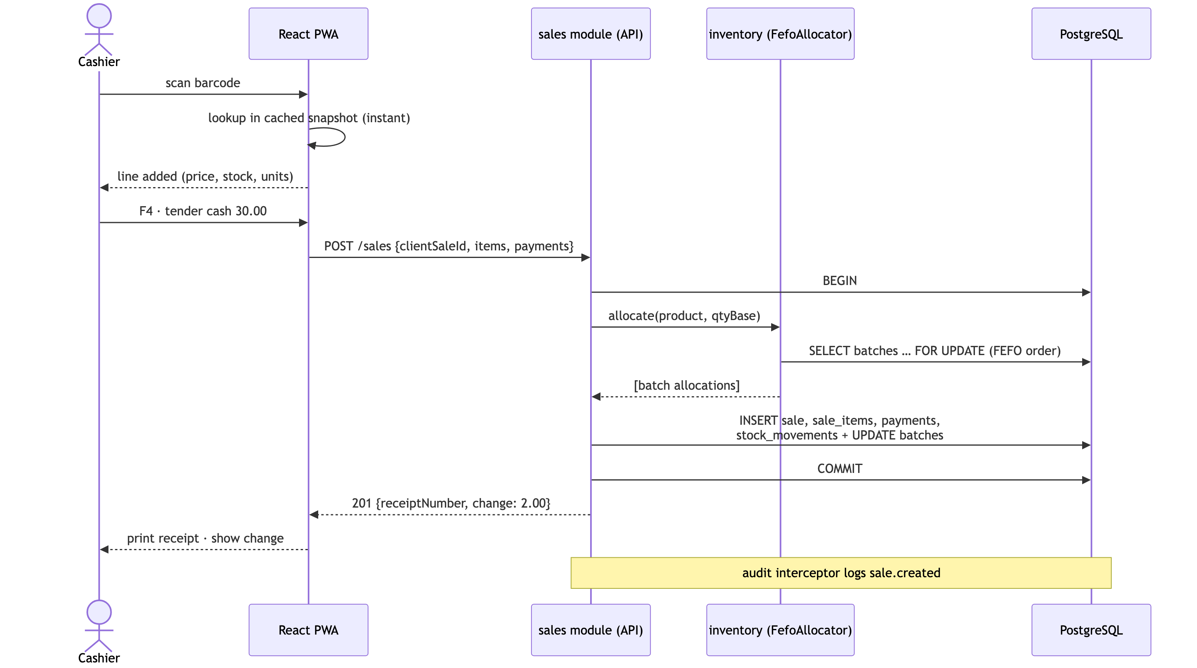
Figure 10

11. Sequence diagram — Offline sale & sync (ADR-006)
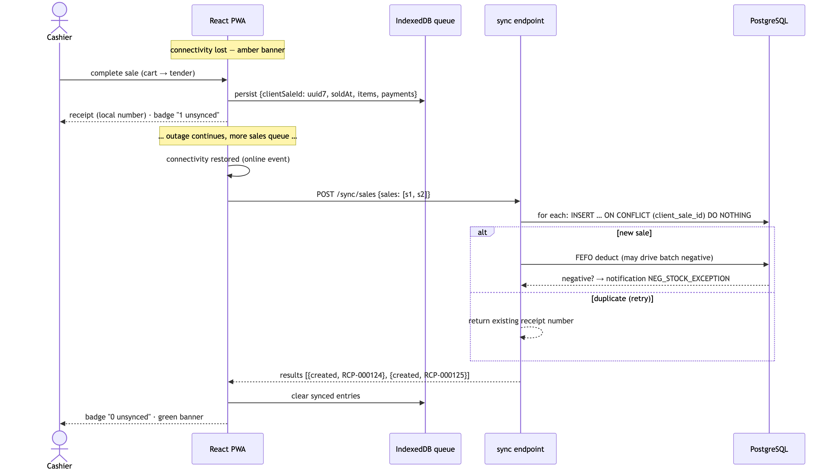
Figure 11

12. Sequence diagram — Login & token refresh (ADR-005)
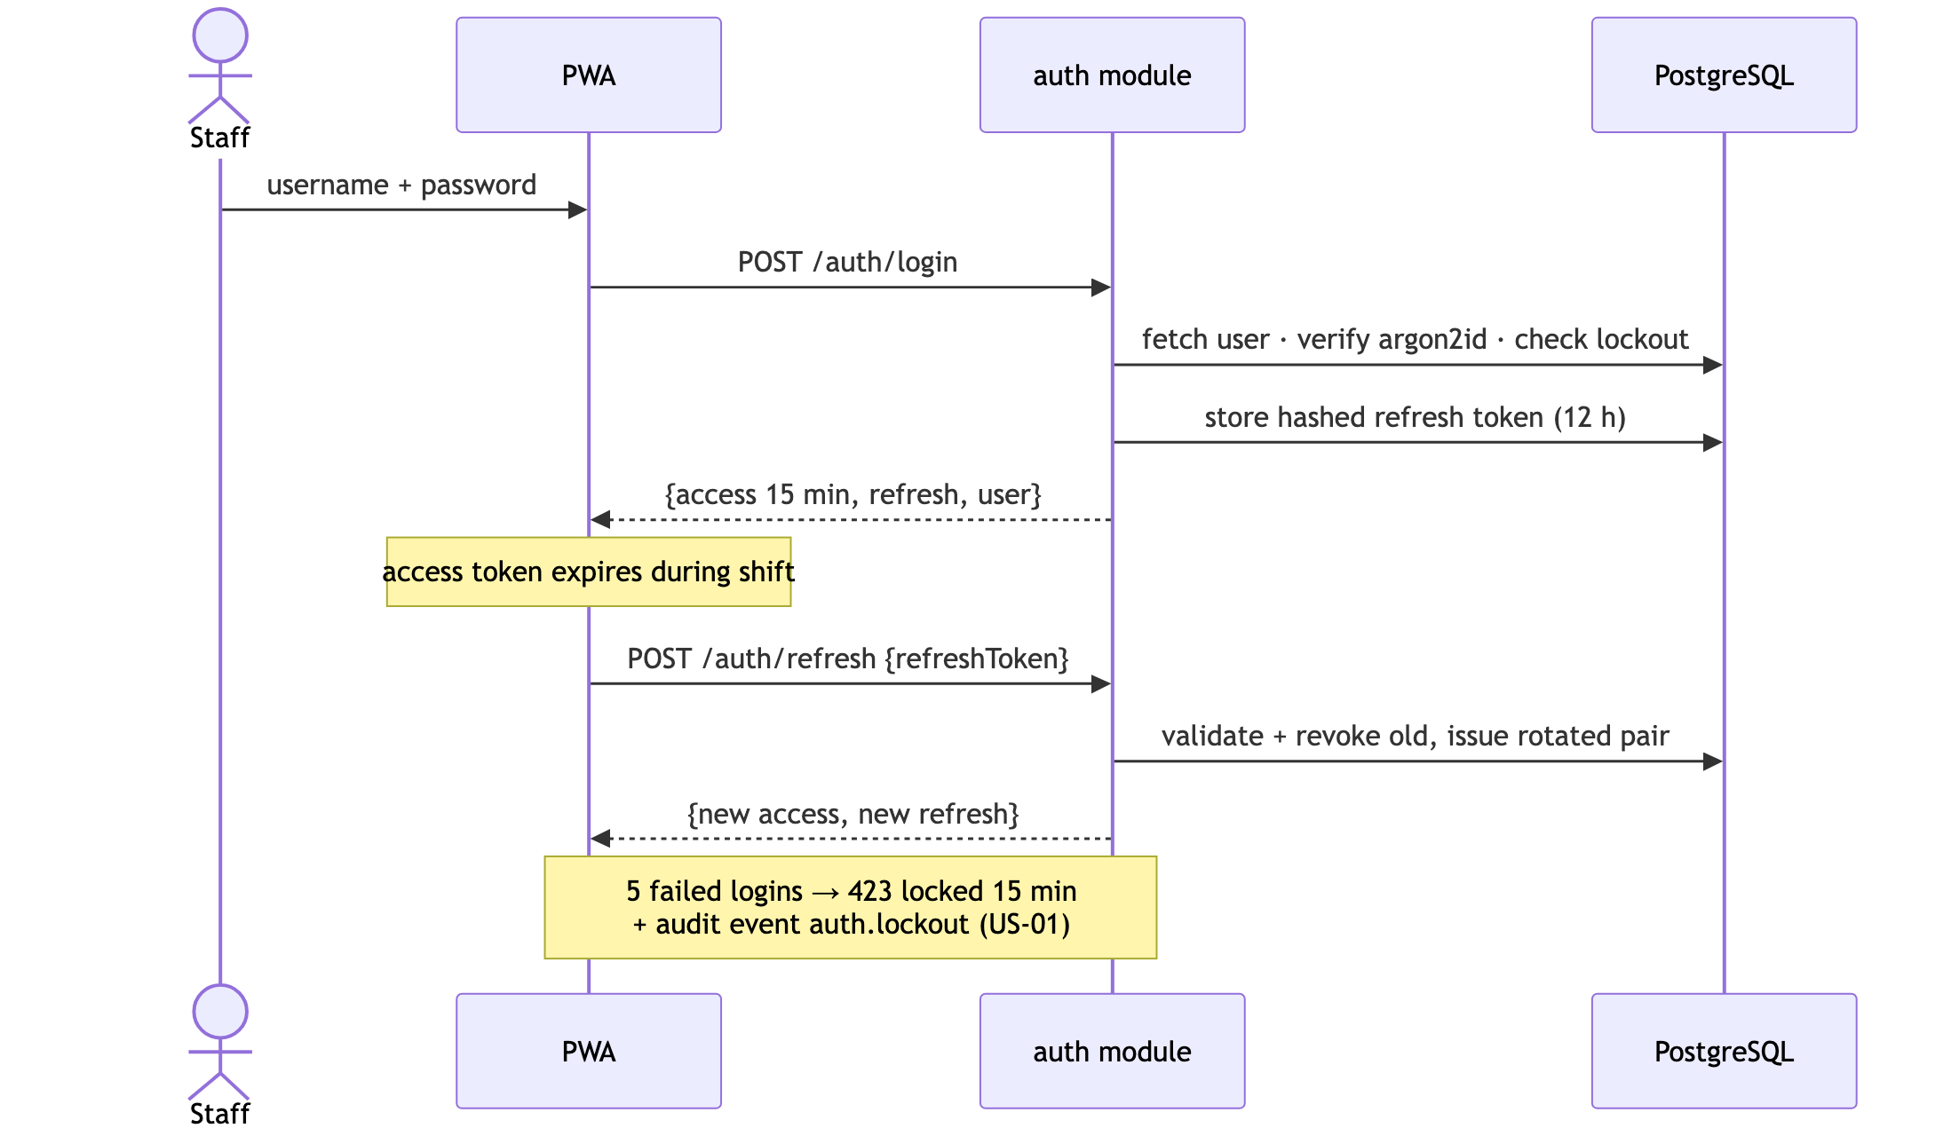
Figure 12

Project Plan — Schedule, Roles, Risks, Milestones, Acceptance
Owner: Project Manager · Aligned to the COE 454 nine-week arc (brief §4–§5).

1. Schedule (Weeks 1–9)
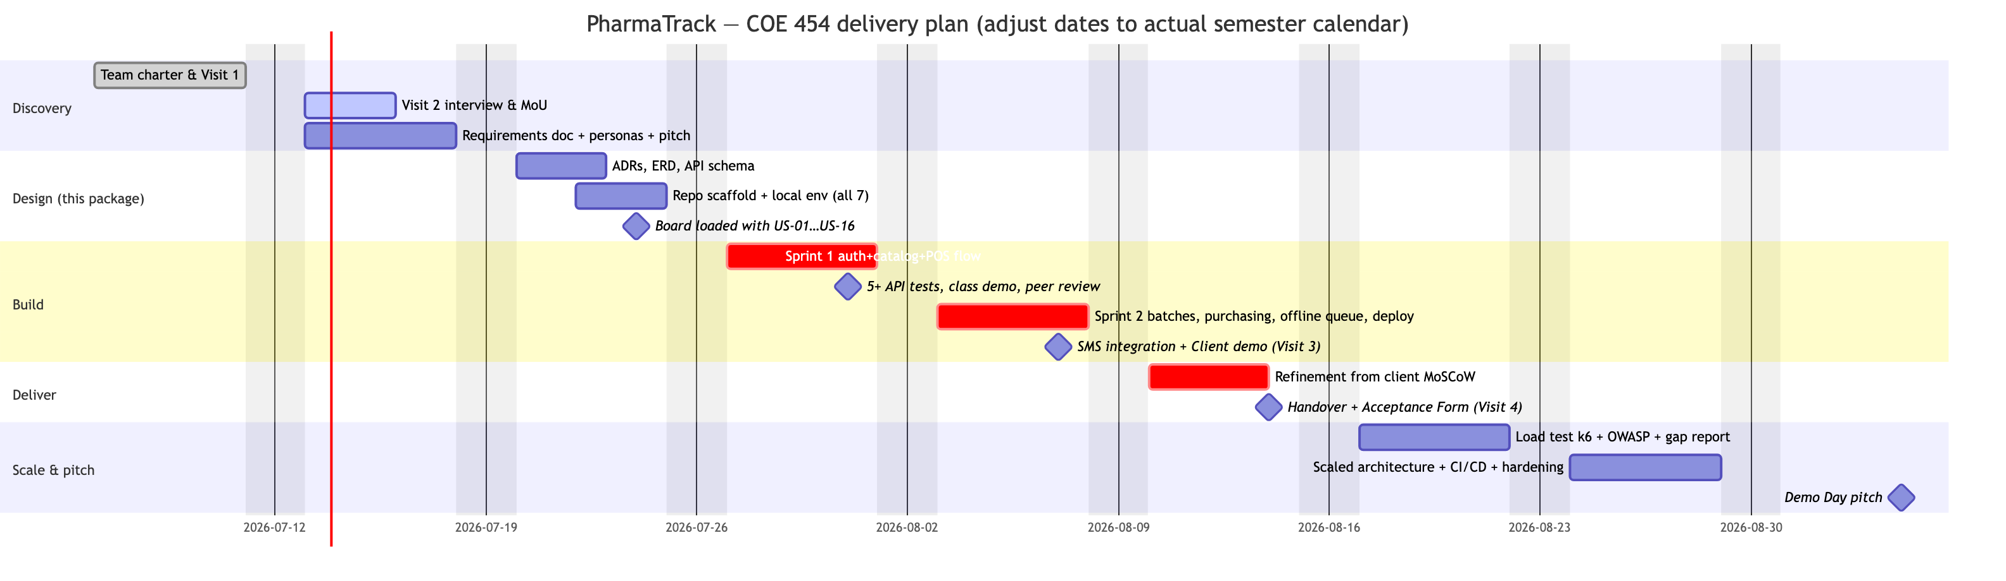
Figure 1

2. Sprint scope mapping
Sprint | Course requirement | Stories
Sprint 1 (Wk 4) | Auth + primary data model + one full workflow + 5 tests | US-01, US-02, US-03, US-04, US-06 (cash only), US-07
Sprint 2 (Wk 5) | 3rd-party integration + live deploy + mobile 3G | US-05, US-09, US-10, US-11, US-13 (daily + low-stock + expiry), US-08 (offline queue), SMS alerts (Africa’s Talking)
Wk 6 refinement | Client MoSCoW Must/Should items | US-12, US-14/15/16 as capacity allows + client feedback
The primary data model for Sprint 1 is Product + ProductUnit (the client’s core entity); batches land early in Sprint 2 so receiving can be demoed to the client.

3. Team roles (course-mandated; fill names in the Team Charter)
Role | Owns in this project
Project Manager | Board, standups, Gantt above, Visit scheduling, final pitch
Business Analyst | Requirements doc, visit logs/evidence, MoU, client sign-offs, feedback forms
UX / Design Lead | wireframes-ui-ux.md, Figma redraws, usability checks pre-demo, 3G/mobile verification
Backend Engineer ×2 | ADRs, schema.sql/Prisma, API modules, sync endpoint, deployment
Frontend Engineer | PWA, POS screen, offline queue, printing, dashboard
QA / Documentation Lead | Test plan + Jest/Supertest suites, README reproducibility, OWASP checklist (Wk 7), k6 load test, portfolio compilation

4. Milestones & acceptance criteria
# | Milestone | Acceptance criteria (evidence)
M1 | Wk 1 package submitted | Signed charter PDF; signed Visit 1 log + photo; discovery note; repo live
M2 | Requirements agreed | Doc ≥5 pages; ≥10 stories with ACs; MoU signed by client + lecturer; pitch delivered
M3 | Design complete | ≥5 ADRs; ERD ≥4 entities; API schema; board screenshot with all stories as issues; every member runs the scaffold locally
M4 | Sprint 1 demo | Live class demo: login → product CRUD → cash sale → receipt; test runner screenshot ≥5 passing
M5 | MVP live | Public URL works on a phone over 3G; client demo held; SMS alert screenshot; feedback form + MoSCoW backlog
M6 | Client acceptance | Signed MVP Acceptance Form; user guide ≤2 pages handed over; credentials transferred; retrospective note
M7–M9 | Scale & pitch | Gap analysis report; CI/CD green on main; k6 results; 10-min pitch with client on panel
MVP acceptance (product-level): a cashier with 2 h training completes a scanned, multi-unit cash sale with printed receipt in <90 s; stock decreases correctly by FEFO; pulling the network cable does not stop selling and queued sales sync on reconnect; the owner opens the dashboard on a phone and sees today’s takings, low-stock and expiring lists; the QB item list has been imported or a dated plan for it is agreed with the client.

5. Risk register
# | Risk | L | I | Mitigation / owner
R1 | Client unavailable for Visit 2/3 scheduling | M | H | Book both visits at MoU signing; BA keeps a fallback contact; escalate to lecturer early (brief allows support)
R2 | Scope creep — “pharmacy software” is bottomless | H | H | MoSCoW frozen after Wk 2; Won’t-have list in writing; PM guards sprint scope; new asks → Wk 6 backlog
R3 | Offline sync bugs corrupt stock | M | H | ADR-006 design (append-only, idempotent); sync endpoint has the densest test coverage; negative-stock exceptions surfaced, never hidden
R4 | QB CSV export impossible/dirty | M | M | Verify export at Visit 2 (Open Q9); fallback = top-200 products entered manually during training week
R5 | Only 1–2 members can actually code | M | H | Exemplar module pattern (ADR-003); pairing rota; non-coders own tests-as-specs, data entry, docs
R6 | Free-tier hosting sleeps/expires mid-demo | M | M | Railway (no cold sleep) per ADR-007; screen-recording backup mandated by brief §4.5.2; uptime ping
R7 | Receipt printer incompatible with browser print | L | M | Print-to-PDF fallback proves the flow; kiosk silent-print flag; ESC/POS spike only if needed (ADR-008)
R8 | Team member non-delivery 2+ weeks | M | M | Charter §5 escalation; PM notifies lecturer in writing (required); peer-eval transparency
R9 | Client data mishandled (Act 843 / MoU §4) | L | H | Seed/demo data only in repos and AI tools; real data only in prod DB; deletion at semester end
R10 | Demo-day connectivity failure | M | M | Backup recording; offline mode is itself the star feature — rehearse the offline demo path

6. GitHub board setup (Week 3 checklist)
- Project board: Backlog / In Progress / In Review / Done
- US-01…US-16 created as issues, each with its acceptance criteria as task list
- Labels: sprint-1, sprint-2, wk6-refinement, module:*, bug, client-feedback
- Branch protection on main: PRs only, 1 review required
- .env.example committed; .env gitignored; CI: lint + test on PR
- Screenshot the loaded board → Week 3 submission

7. Future improvements (post–Week 9 / Phase 2 pitch material)
- Multi-branch + stock transfer — the schema’s movement ledger extends with a location_id; the Multistore capability their QB edition nominally had.
- MTN MoMo / Paystack payment capture at the till with automatic reconciliation.
- E-prescription capture and prescriber records for controlled medicines (BR-08 full).
- Demand forecasting for reorder suggestions (moving average → ML later — deliberately excluded from MVP per brief §3.2 guidance).
- NHIS/insurer billing export.
- ESC/POS native printing + cash drawer kick.
- Supplier portal / WhatsApp PO delivery via WhatsApp Business API.
- Read-replica + job queue split — the Week 8 scaling exercise turns module seams (ADR-001) into deployment seams: reporting on a replica, notifications on a worker.

